**WS14-EXAM INSPECTION**

**CODE**

1) running program /10 pts.

2) Printing books on screen /10 pts.

3) Total amount of money for the books /10 pts.

4) Code Quality /10 pts.

5) UML Class Diagram /10 pts

**DATE: 02th december 2021**

1 ALMACHE LITARDO ANDERSON MOISES

1) running program 4/10 pts.

2) Printing books on screen 5/10 pts.

3) Total amount of money for the books 2/10 pts.

4) Code Quality 5/10 pts.

5) UML Class Diagram 6/10 pts

Total: 22 pts

inspector: Altamirano Cristhian

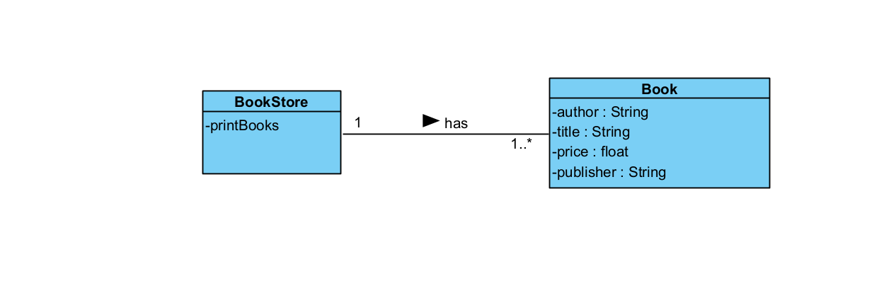

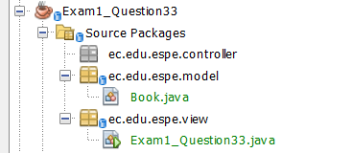

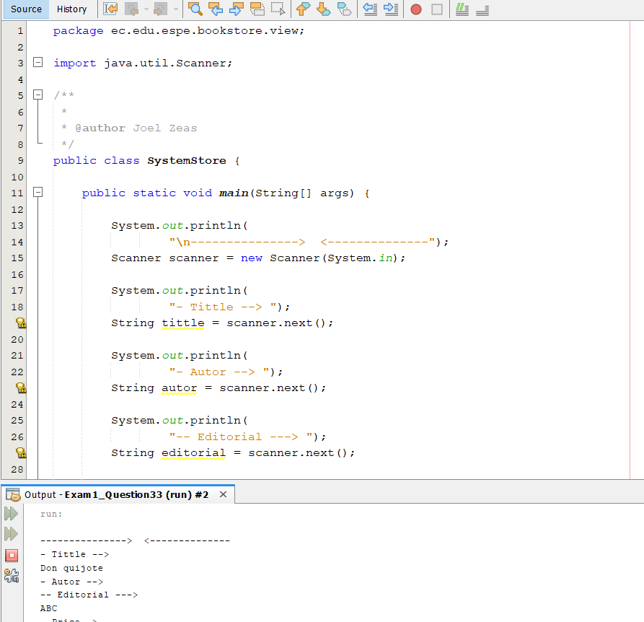

2 ALTAMIRANO BENALCAZAR CRISTHIAN ALEXANDER

1) running program 6/10 pts.

2) Printing books on screen 6/10 pts.

3) Total amount of money for the books 0/10 pts.

4) Code Quality 8/10 pts.

5) UML Class Diagram 6/10 pts

Total: 26

inspector: Alvarez Michelle.

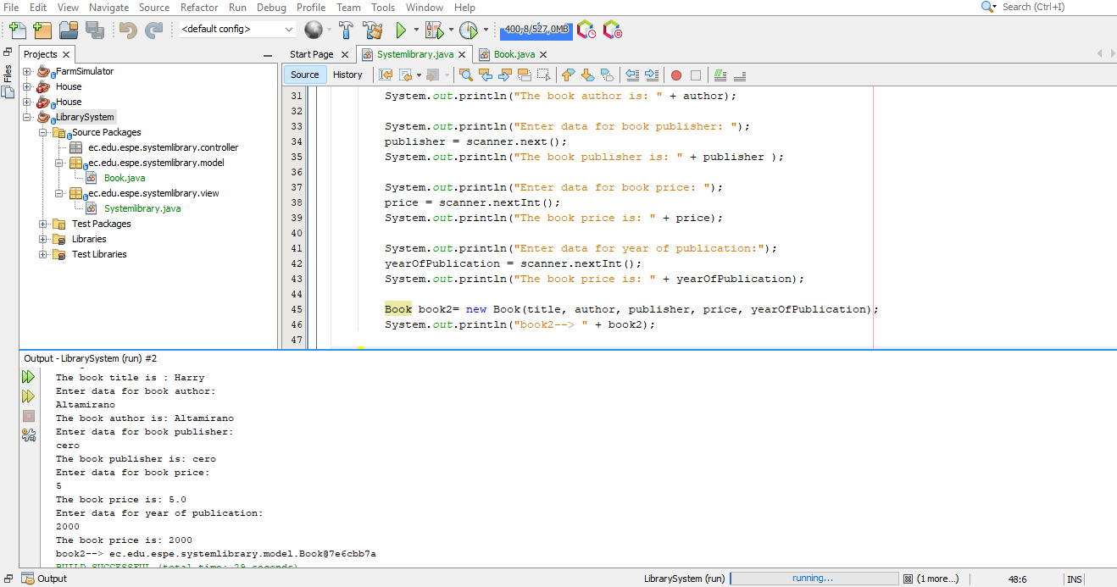

3 ALVAREZ RAMIREZ MICHELLE ESTEFANIA

Inspector: ANDRADE CARATE ALAN DAMIAN

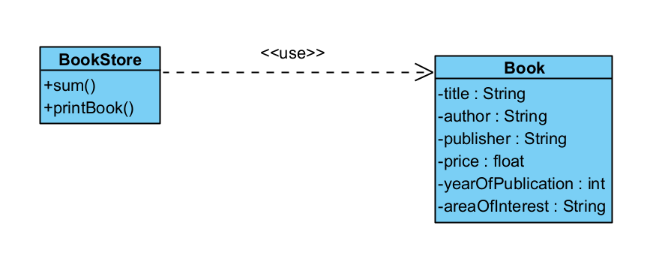

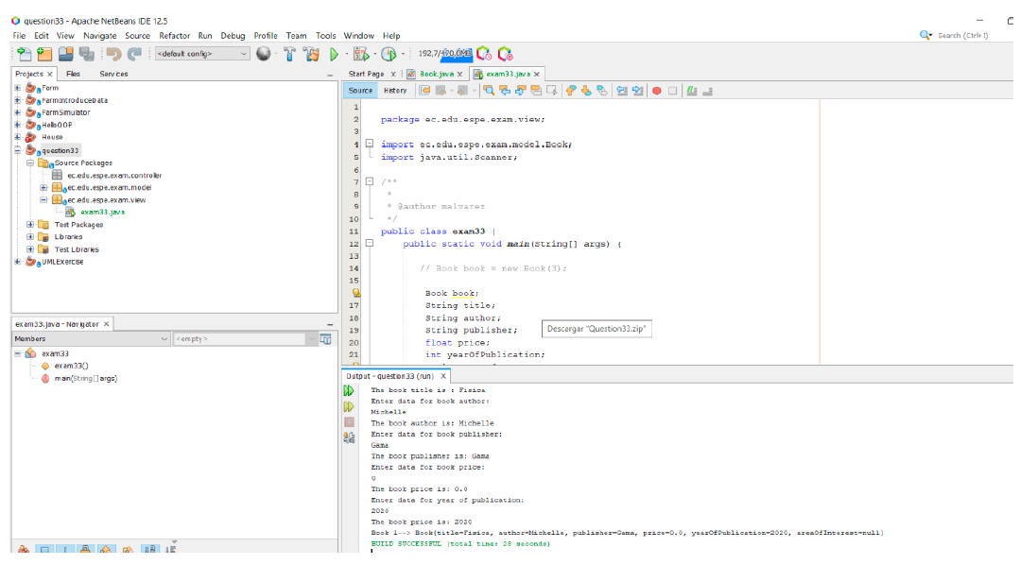

1) running program 5/10 pts.

2) Printing books on screen 5/10 pts.

3) Total amount of money for the books 0/10 pts.

4) Code Quality 8/10 pts.

5) UML Class Diagram 10/10 pts

Total: 28/50 pts

4 ANDRADE CARATE ALAN DAMIAN

Inspector: Andrango Espinosa Alex Paul

1) running program 5/10 pts.

2) Printing books on screen 7/10 pts.

3) Total amount of money for the books 0/10 pts.

4) Code Quality 7/10 pts.

5) UML Class Diagram 10/10 pts

TOTAL: 29/50 pts

5 ANDRANGO ESPINOSA ALEX PAUL

Inspector: Cristhian Arroba

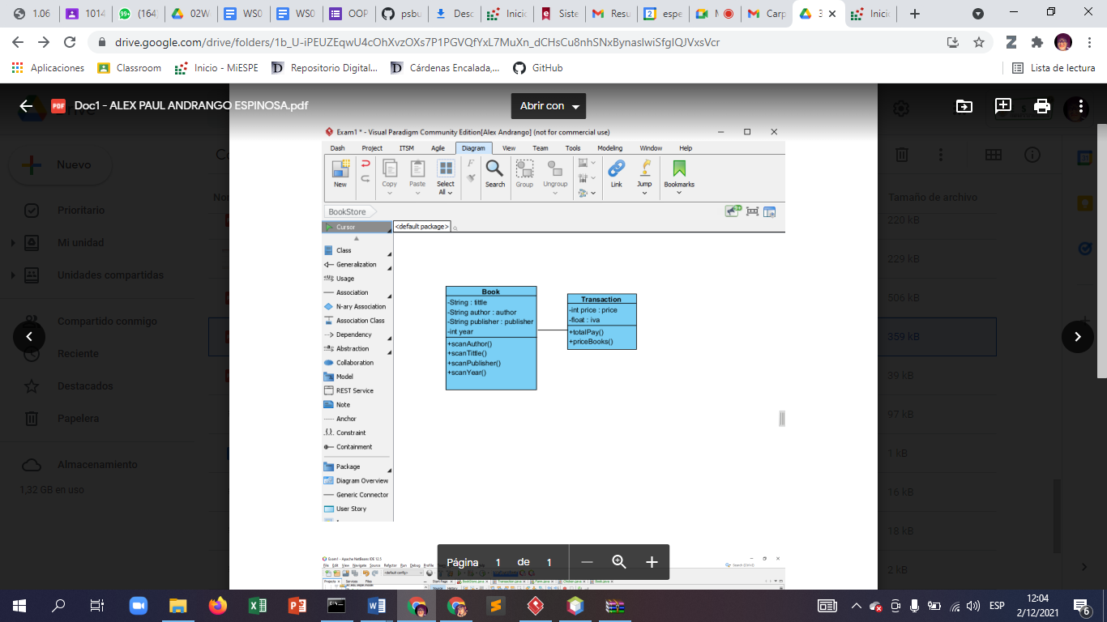

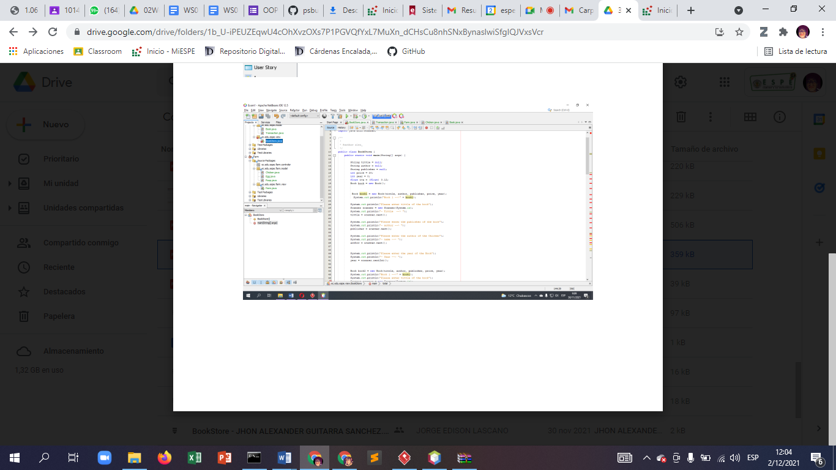

1) running program 5/10 pts.

2) Printing books on screen 7/10 pts.

3) Total amount of money for the books 7/10 pts.

4) Code Quality 10/10 pts.

5) UML Class Diagram 7/10 pts

total: 36/50

6 ARROBA SOLORZANO CRISTIAN ALEXANDER

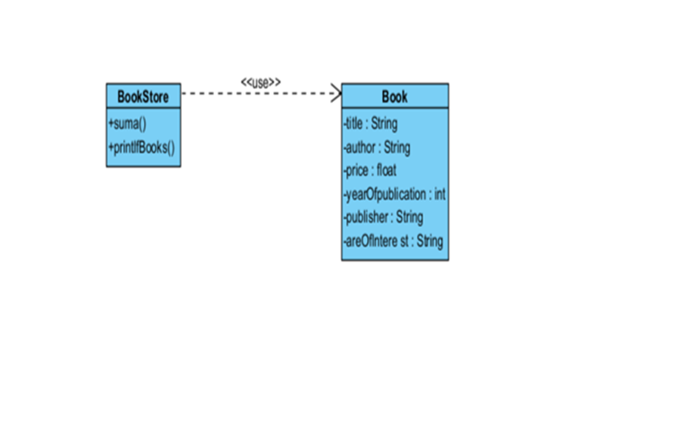

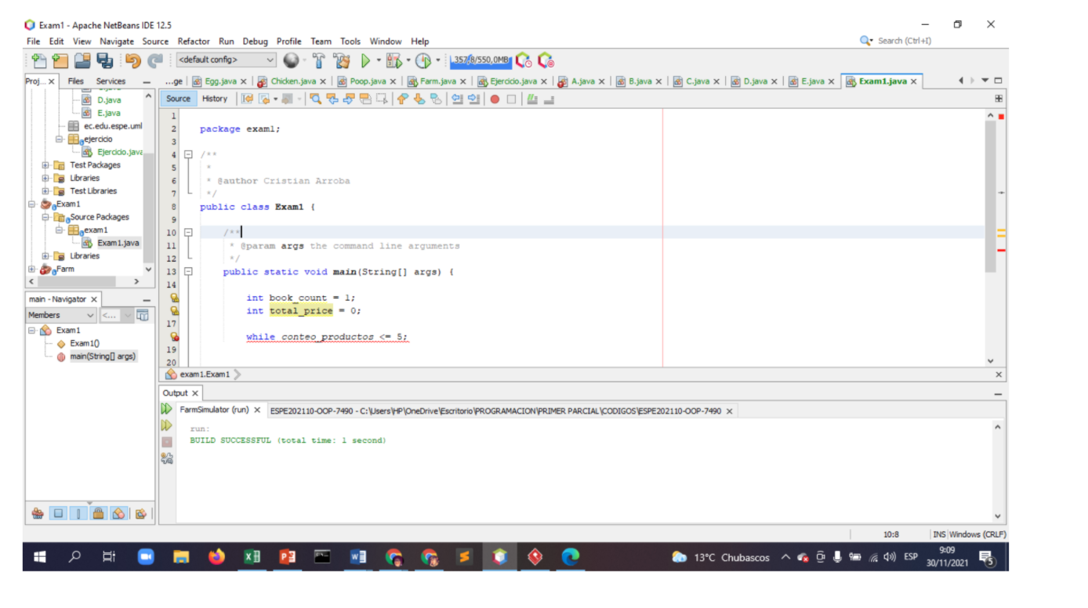

1) running program 0/10 pts.(the program does not run)

2) Printing books on screen 4/10 pts.

3) Total amount of money for the books 0/10 pts. (the program does not run)

4) Code Quality 10/10 pts.

5) UML Class Diagram 14/10 pts

Total: 24/50

7 ASUMAZA GUALOTO DYLAN ALEXANDER

Inspector: Bravo Katherin

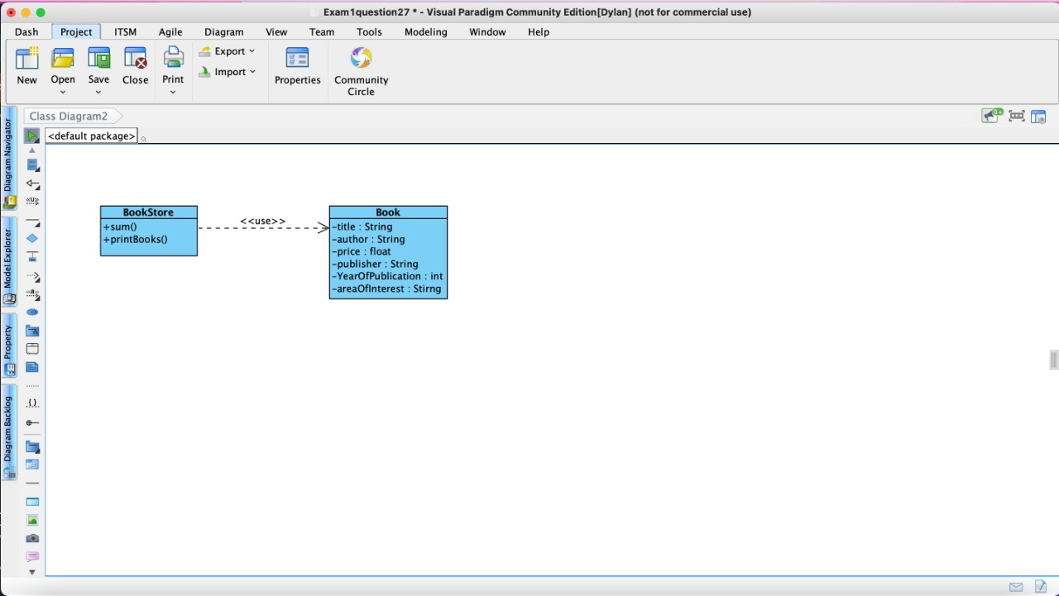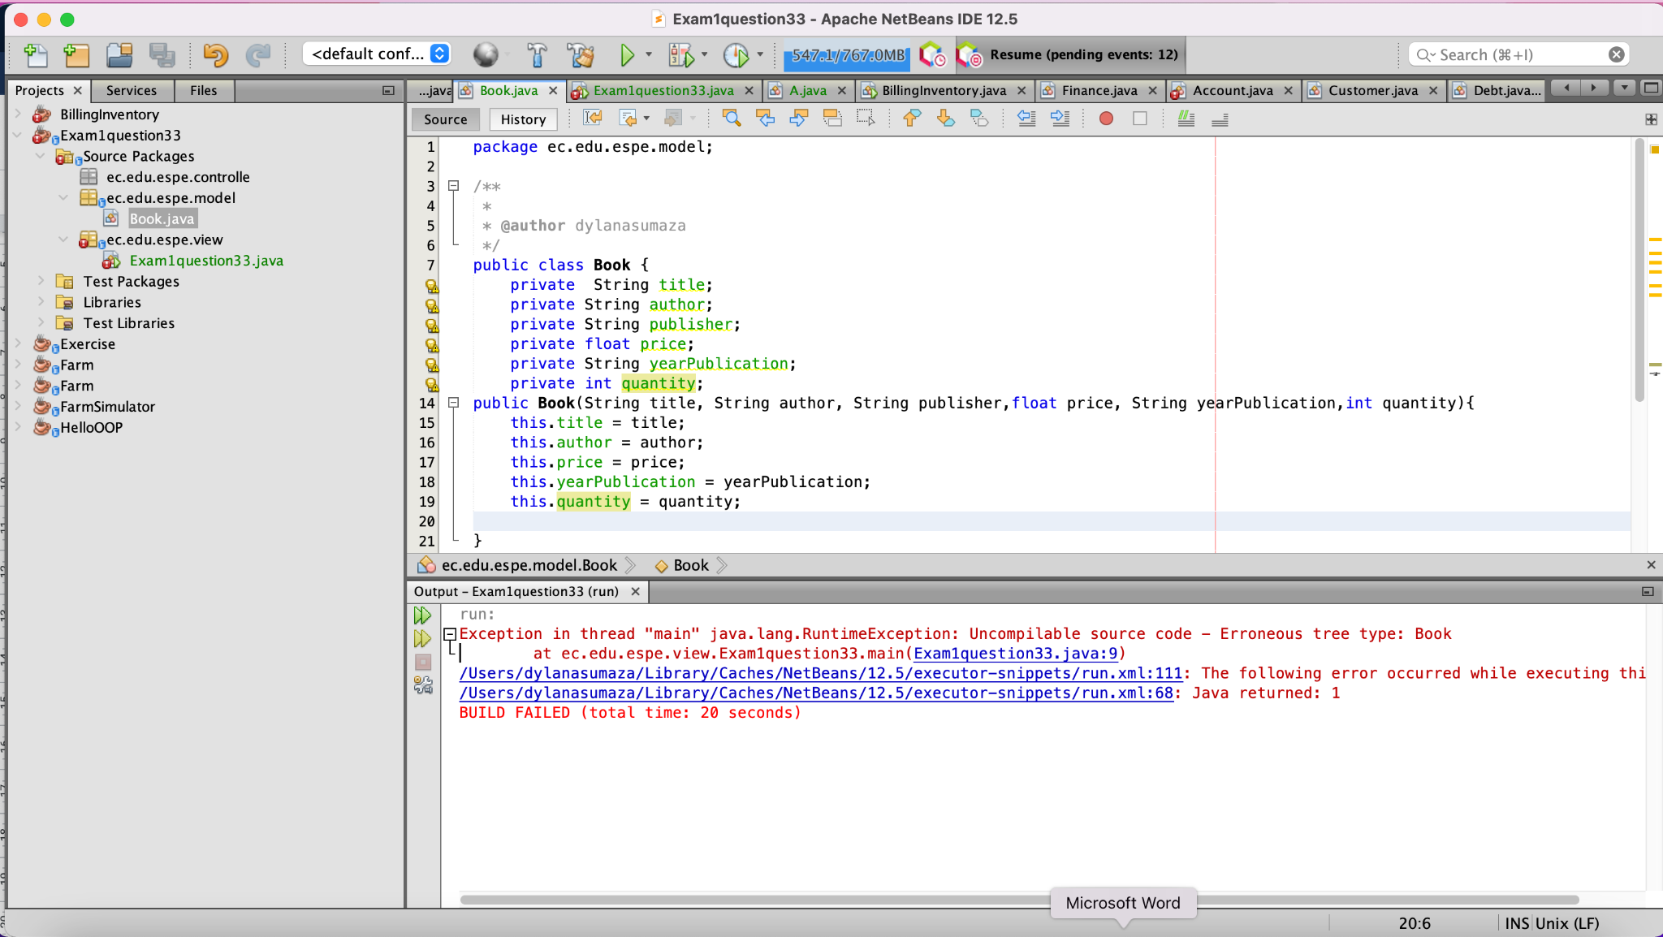

1) running program 0/10 pts.

2) Printing books on screen 5/10 pts.

3) Total amount of money for the books 0/10 pts.

4) Code Quality 10/10 pts.

5) UML Class Diagram 10/10 pts

Total: 25/50

8 BRAVO RODRIGUEZ KATHERIN DAYANNE

INSPECTOR: Christian Bravo

1) running program 5/10 pts.

2) Printing books on screen 5/10 pts.

3) Total amount of money for the books 6/10 pts.

4) Code Quality 6/10 pts.

5) UML Class Diagram 10/10 pts

Total: 32

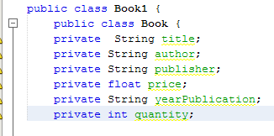

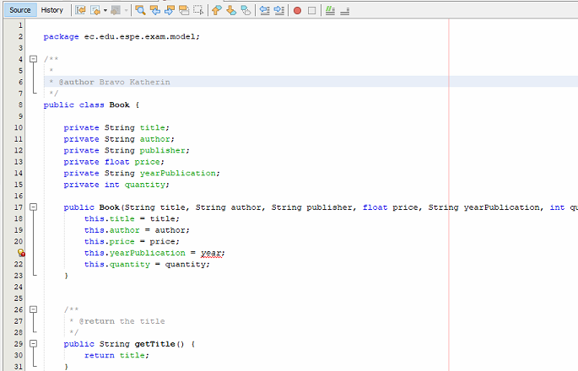

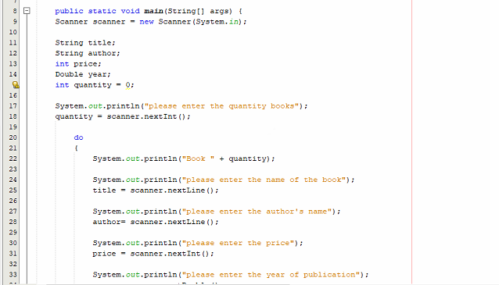

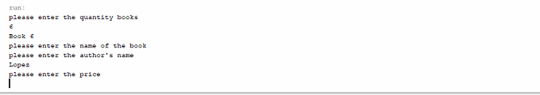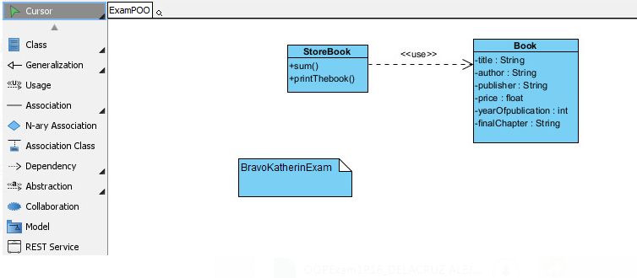

9 BRAVO VILLALOBOS CHRISTIAN DAVID

1) running program 8/10 pts.

2) Printing books on screen 8/10 pts.

3) Total amount of money for the books 0/10 pts.

4) Code Quality 8/10 pts.

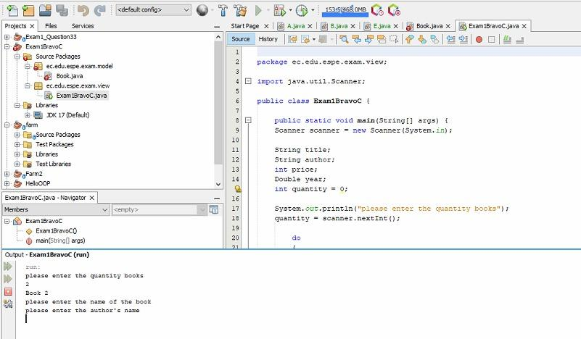

5) UML Class Diagram 10/10 pts

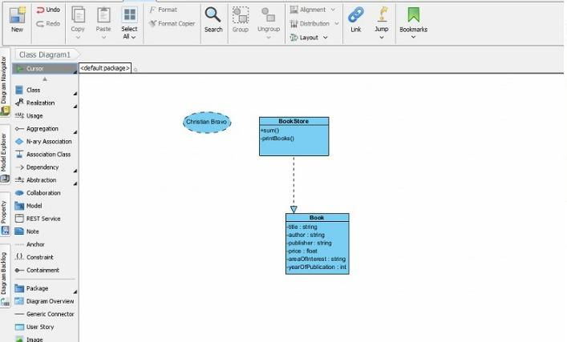

10 BUSTILLOS MONTENEGRO PABLO SEBASTIAN

INSPECTOR: Benjamin Cadena

1) running program 9/10 pts. (failure to calculate IVA on books)

2) Printing books on screen 6/10 pts. (incomplete data printing)

3) Total amount of money for the books 6/10 pts.(does not generate the total well)

4) Code Quality 9/10 pts. (very generalized code)

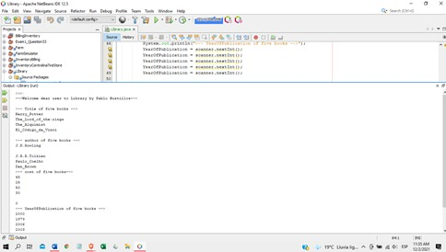

5) UML Class Diagram 10/10 pts

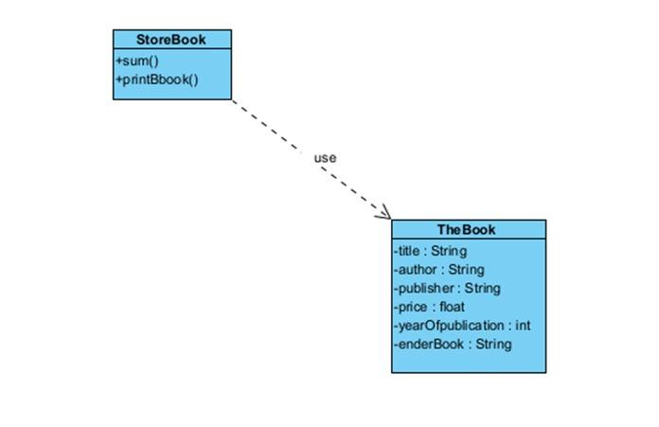

TOTAL:40/50

11 CADENA ROMAN BENJAMIN ABEL

Inspector: Sebastián Caisatoa

1) running program 7/10 pts.(the program runs fine but does not print the iva)

2) Printing books on screen 7/10 pts.

3) Total amount of money for the books. 5/10 pts. (the program prints the price but does not get the iva)

4) Code Quality 7/10 pts. (Variables start with capital letters)

5) UML Class Diagram 9/10 pts (the verb is missing in the dependency)

TOTAL 35/50

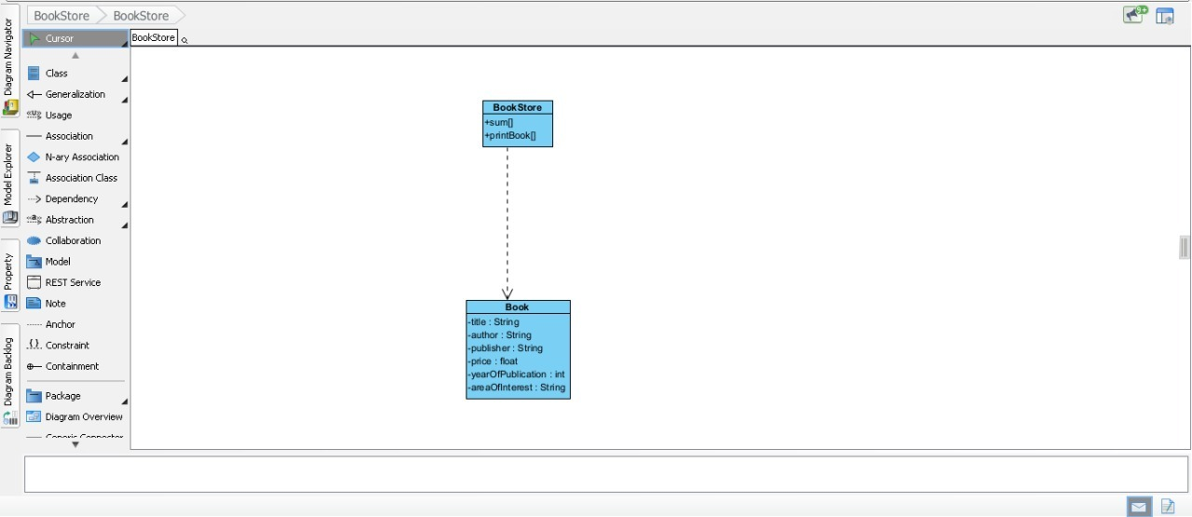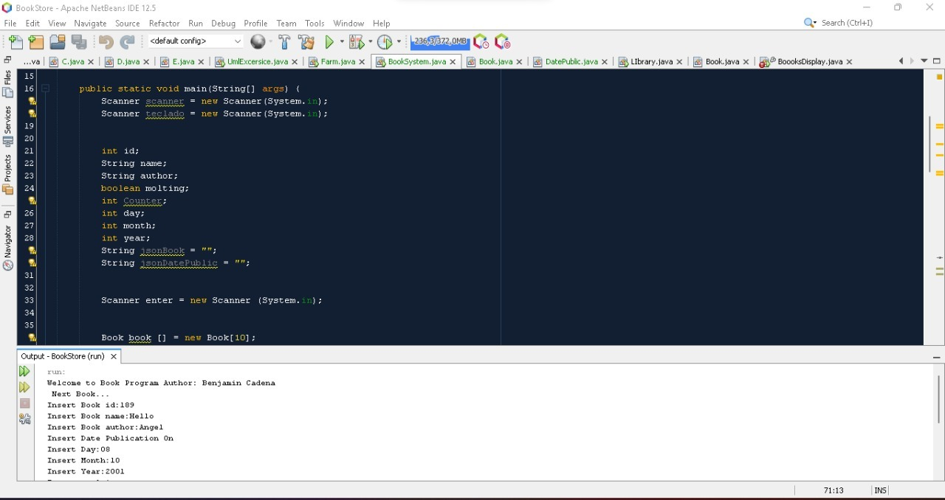

12 CAISATOA RAMIREZ SEBASTIAN BERNARDO

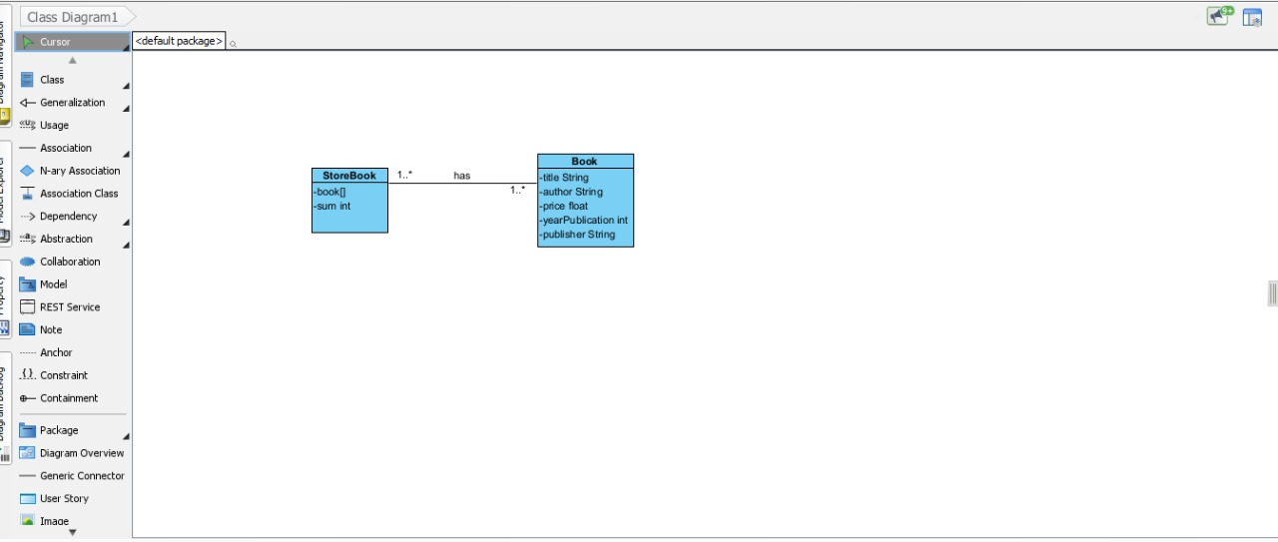

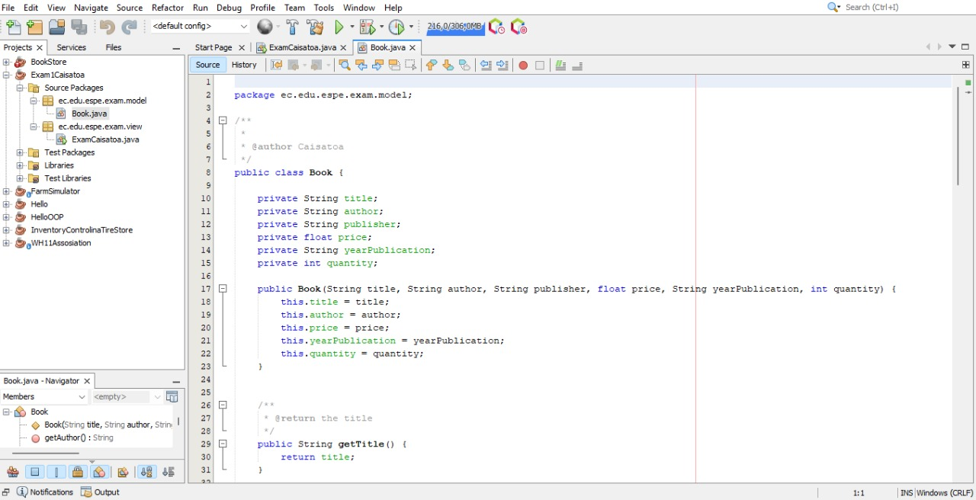

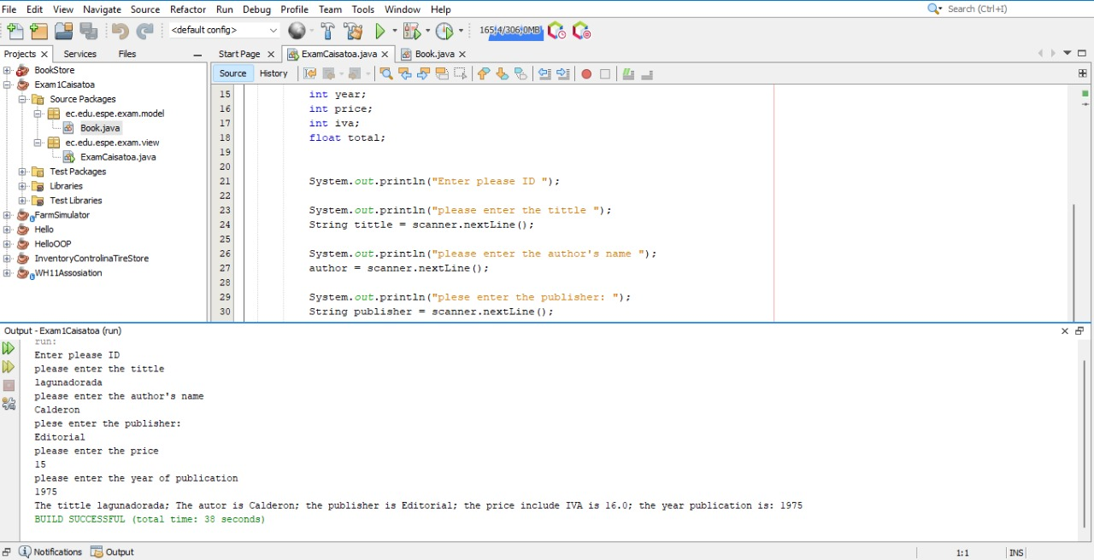

Inspector: Andy Calderón

1) running program 10/10 pts.

2) Printing books on screen 7/10 pts.

3) Total amount of money for the books 7/10 pts.

4) Code Quality 8/10 pts.

5) UML Class Diagram 7/10 pts

Total 39/50

13 CALDERON MERCHAN ANDY JOSUE

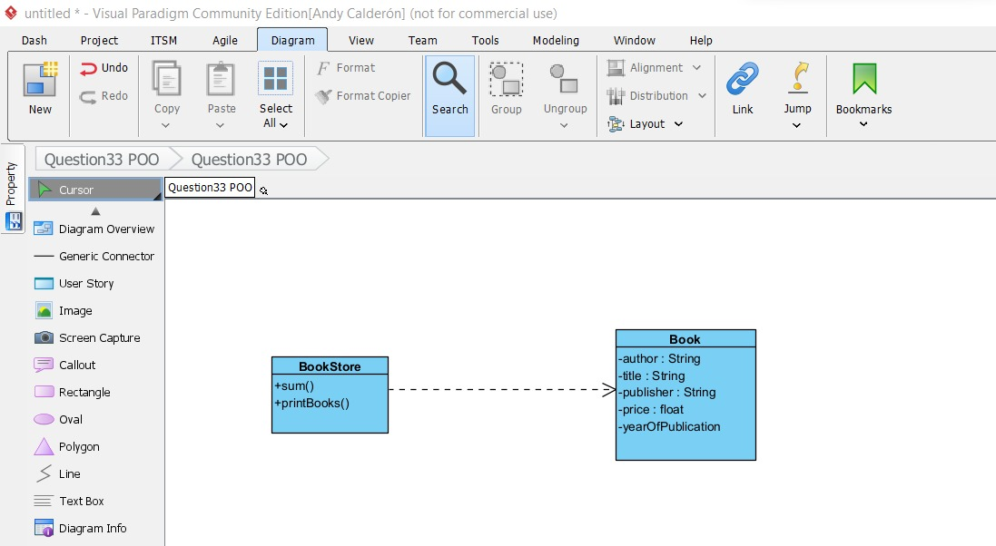

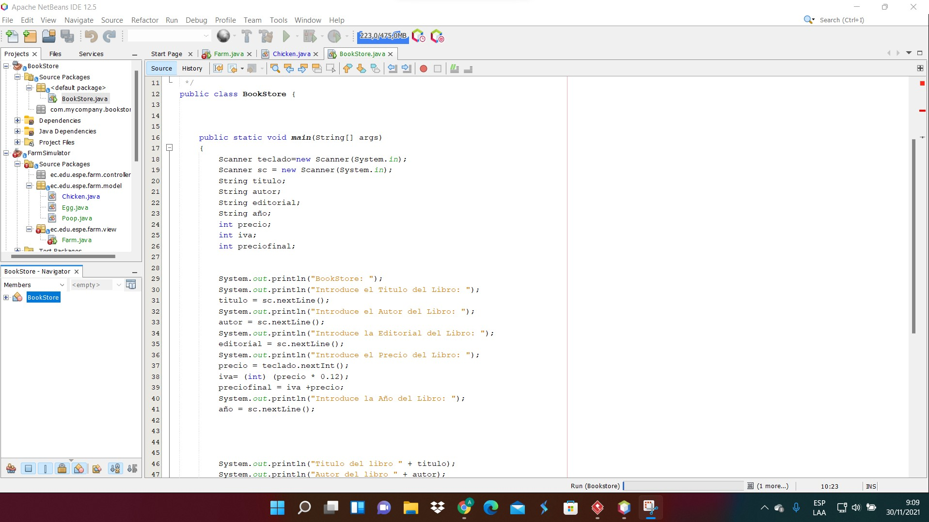

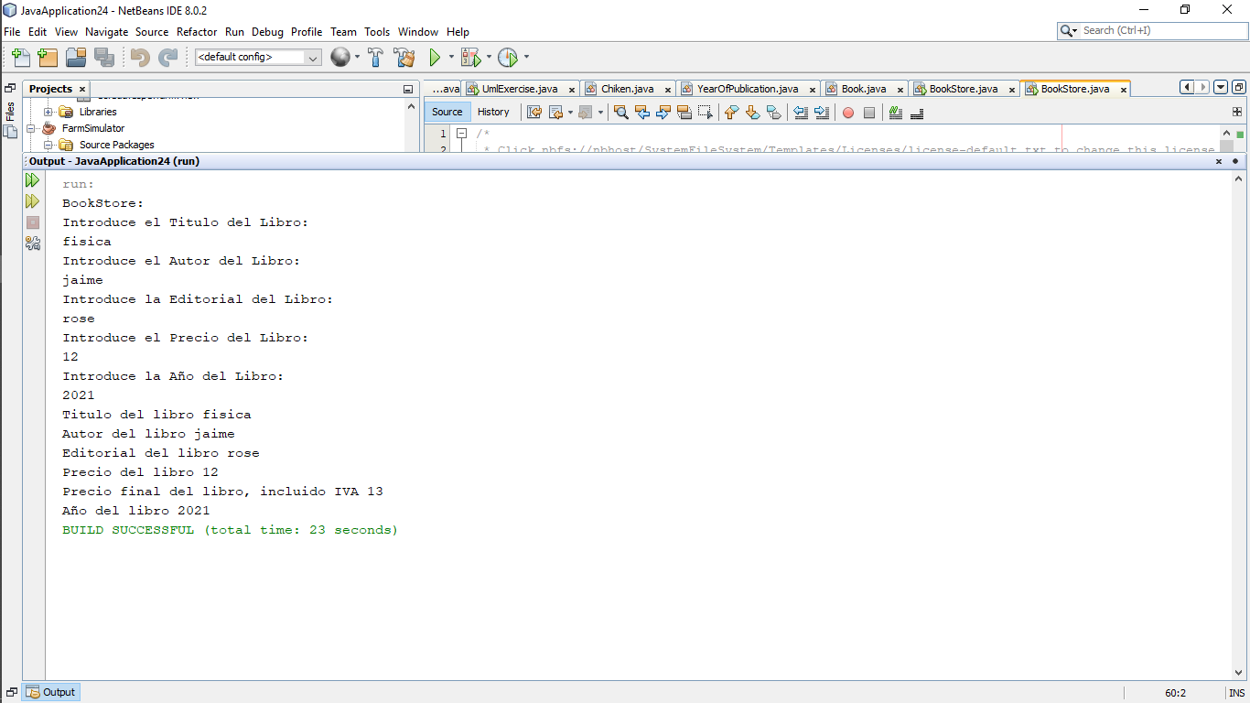

Inspector:Kerly Correa

1) running program 10 /10 pts.

2) Printing books on screen 9 /10 pts.

3) Total amount of money for the books 5/10 pts.

4) Code Quality 9/10 pts.

5) UML Class Diagram 10 /10 pts

Total 43/50pts

14 CORREA RUIZ KERLY YADIRA

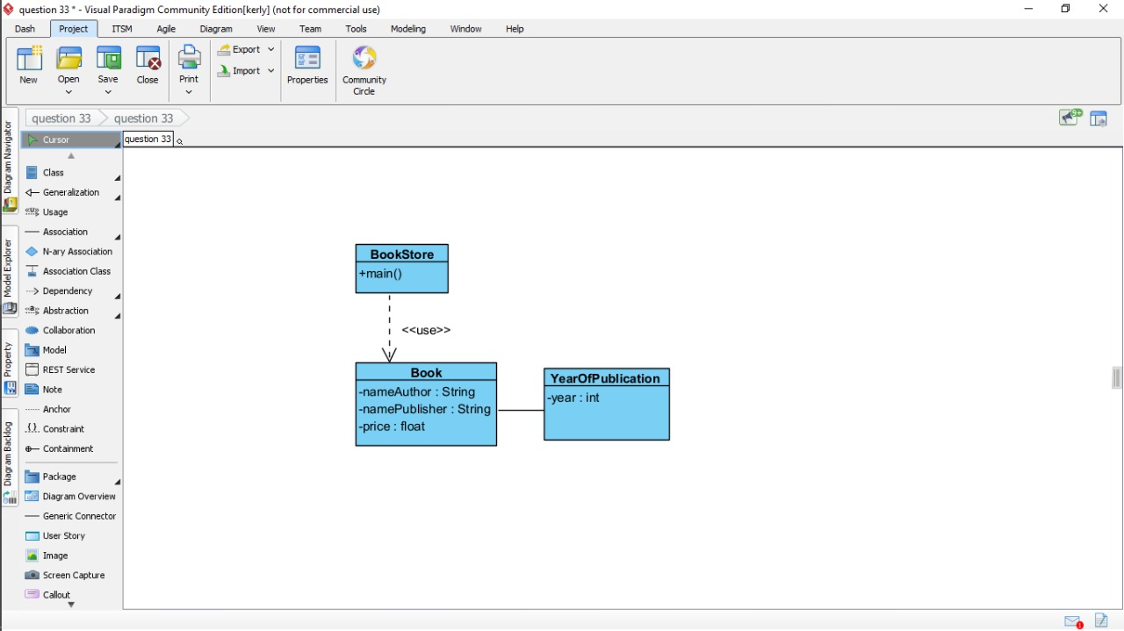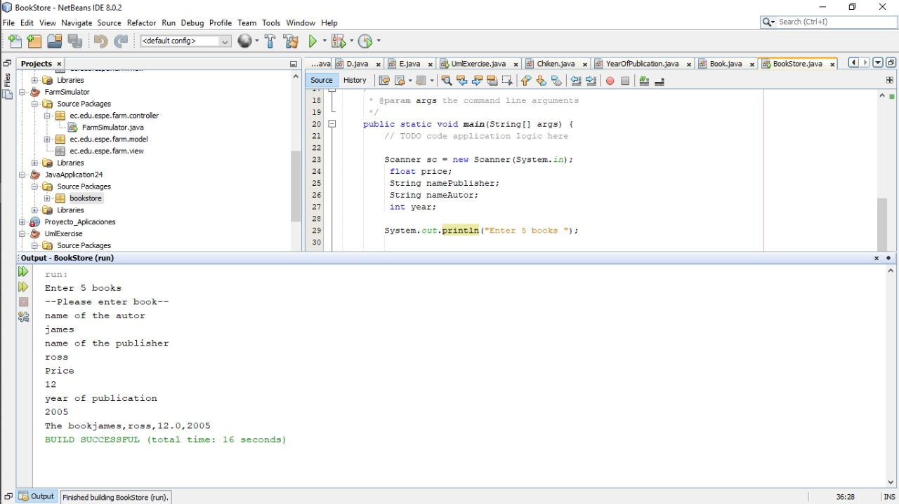

Inspector:Darling Cruz

1) running program 5 /10 pts.

2) Printing books on screen 7 /10 pts.

3) Total amount of money for the books 5 /10 pts.

4) Code Quality 7/10 pts.

5) UML Class Diagram 8 /10 pts

TOTAL 32/50

15 CRUZ PANTOJA DARLING MICAELA

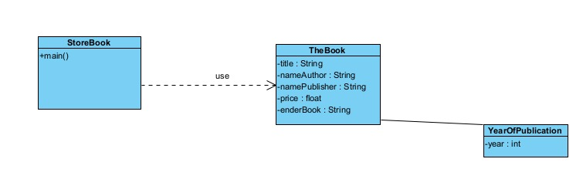

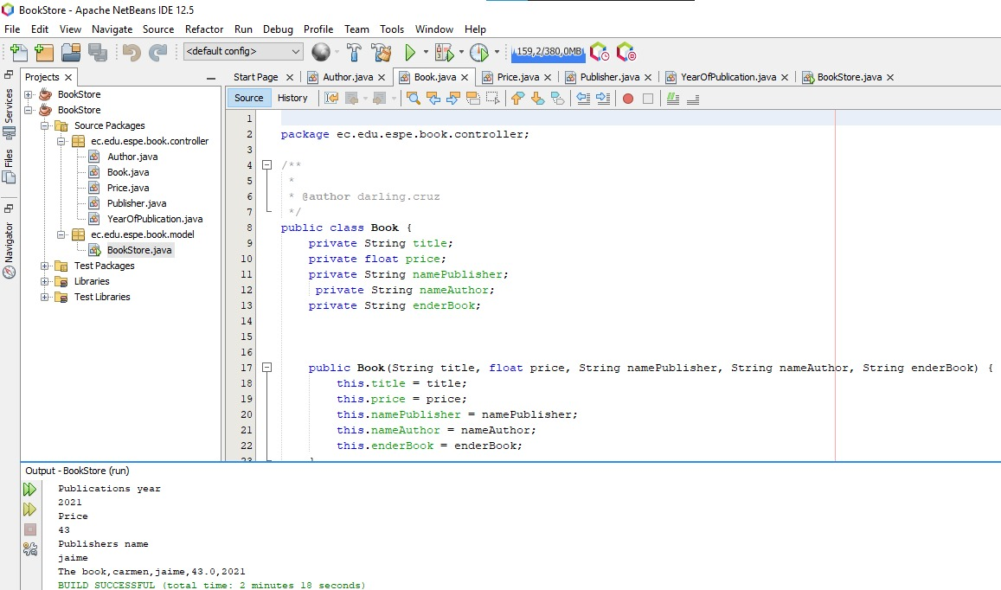

1) running program 5/10 pts.   
2) Printing books on screen 7/10 pts.   
3) Total amount of money for the books 5/10 pts.   
4) Code Quality 6/10 pts.   
5) UML Class Diagram 10/10 pts  
  
Total: 33/50 pts

16 DE LA CRUZ QUINGA ALEJANDRO SEBASTIAN

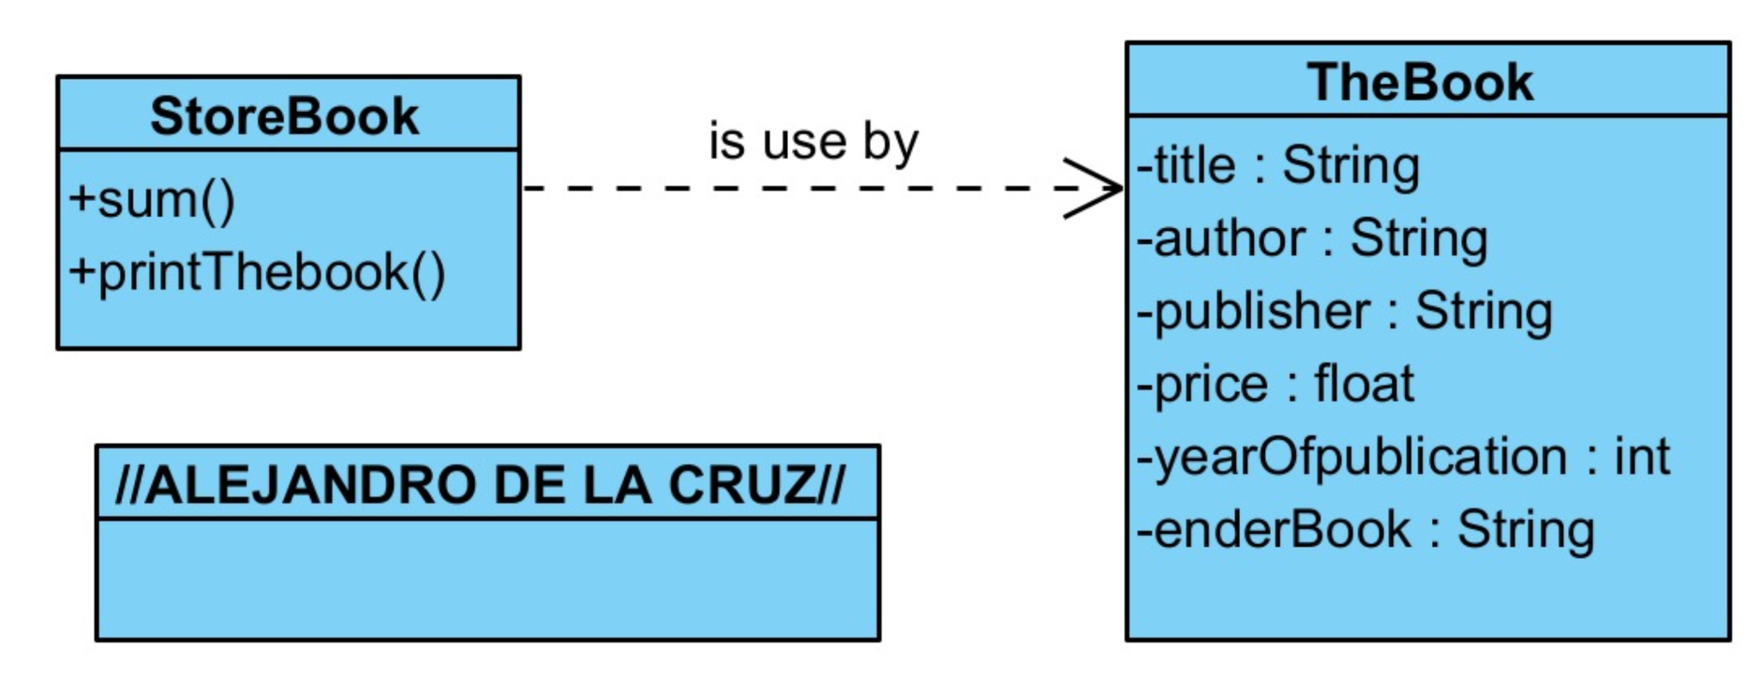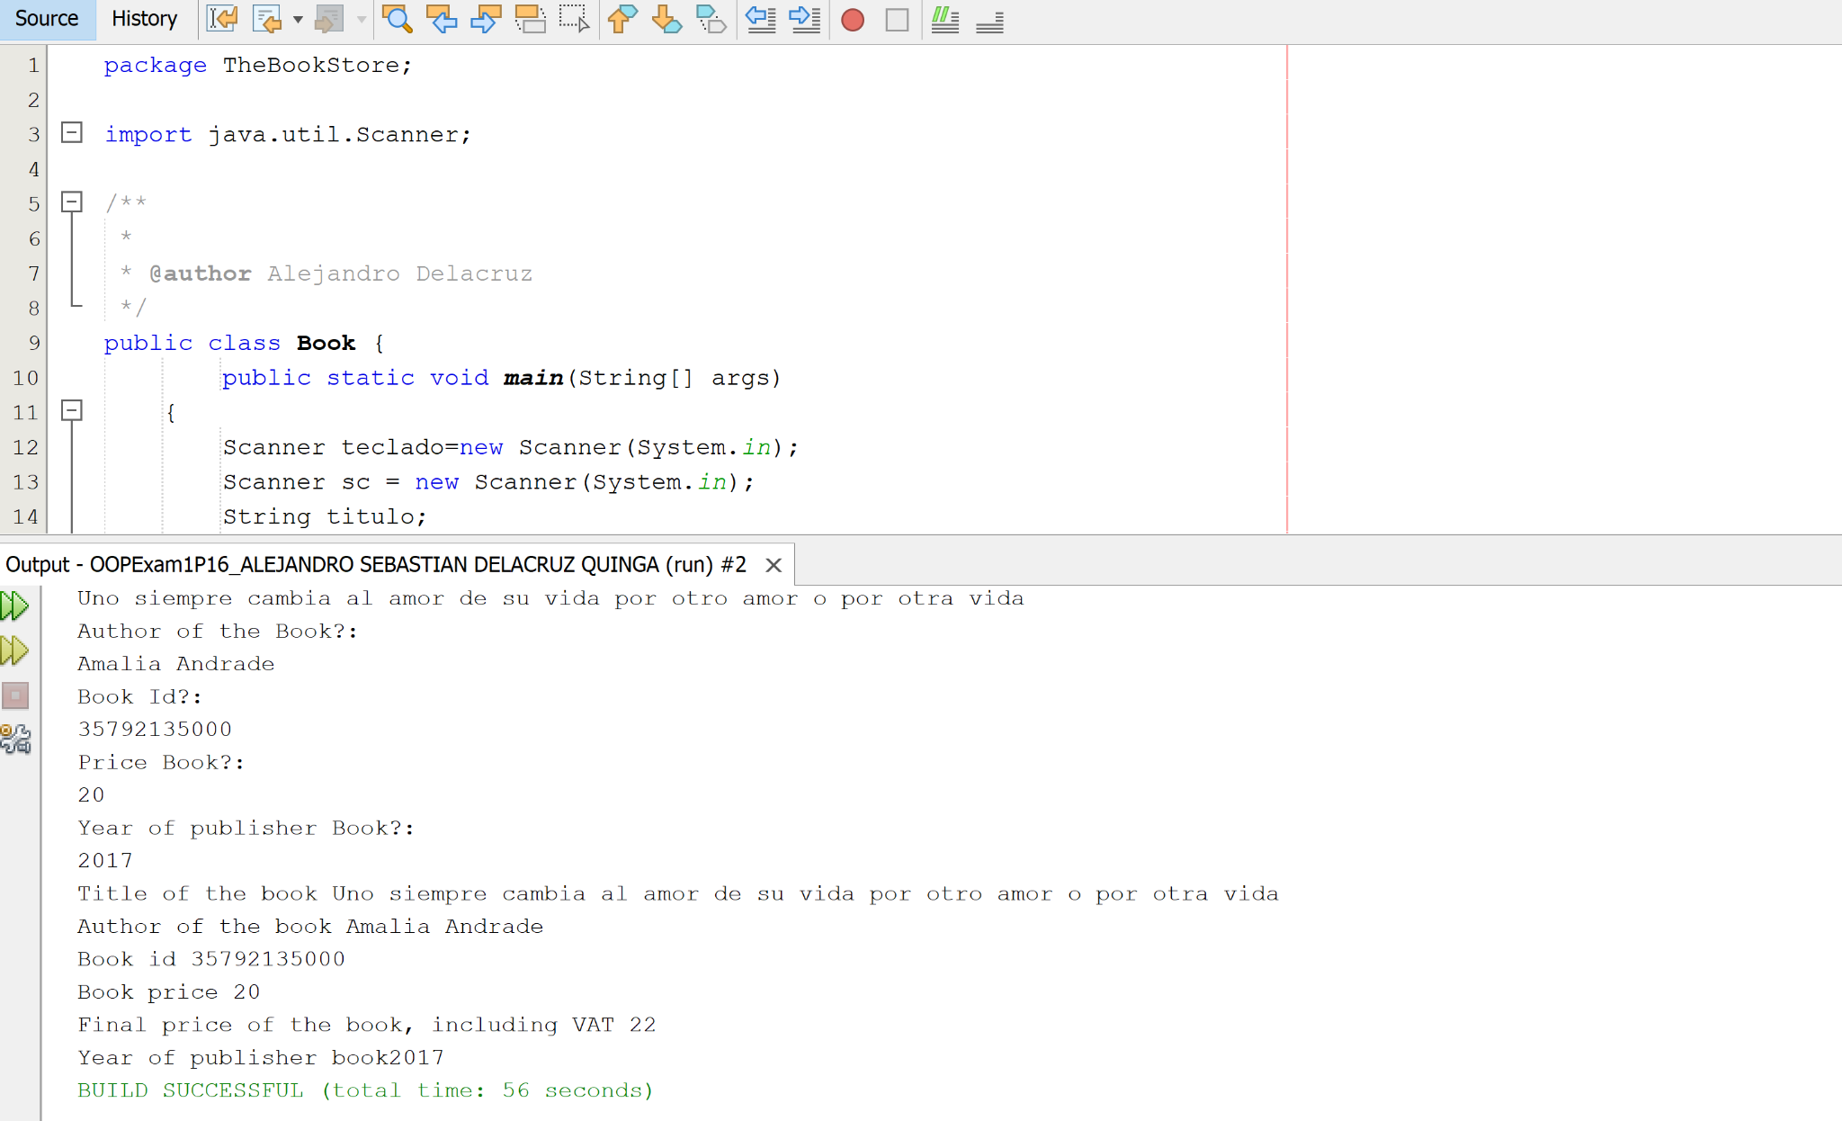  
1) running program 9/10 pts.   
2) Printing books on screen 8/10 pts.   
3) Total amount of money for the books 6/10 pts.   
4) Code Quality 8/10 pts.   
5) UML Class Diagram 9/10 pts  
  
Total: 40/50 pts

17 EIVAR DAGUA JAIME MAURICIO

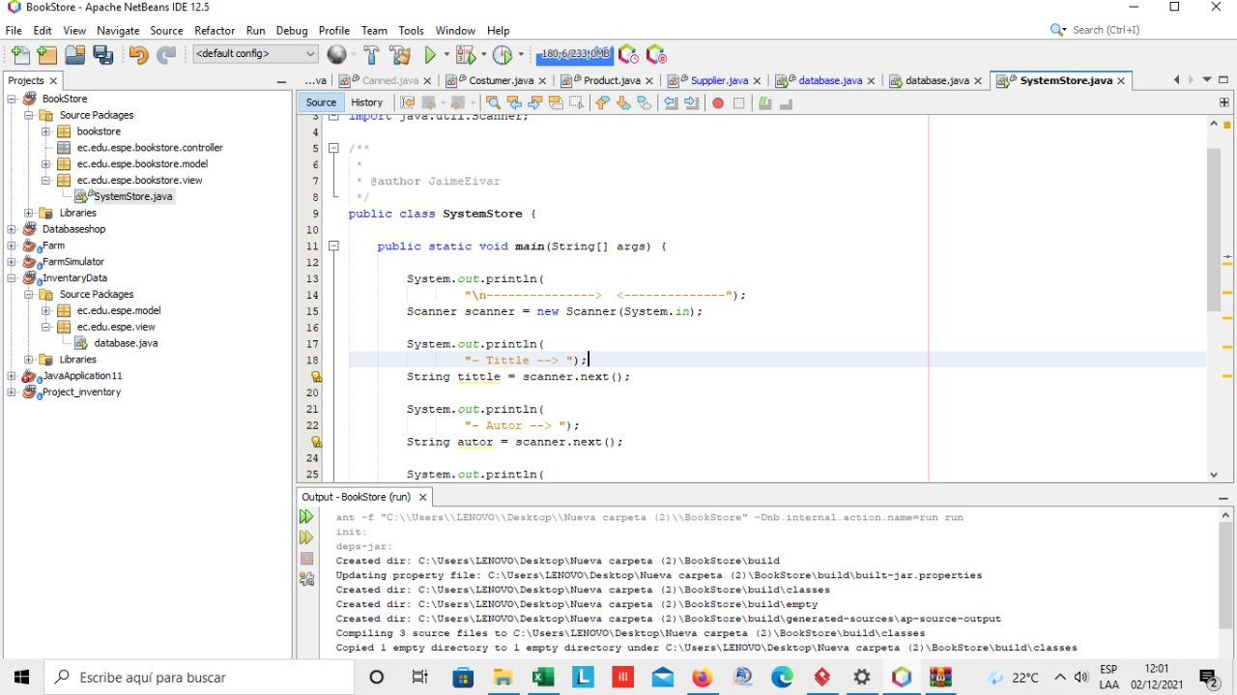

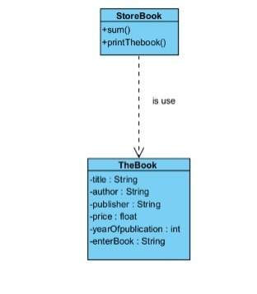

inspector : Mayerly Garcia

1) running program 5/10 pts.

2) Printing books on screen 5/10 pts.

3) Total amount of money for the books 1/10 pts.

4) Code Quality 5/10 pts.

5) UML Class Diagram 10/10 pts

total: 26/50

18 GARCIA BARRETO MAYERLY PRISSILLA

Inspector: Melissa Gómez

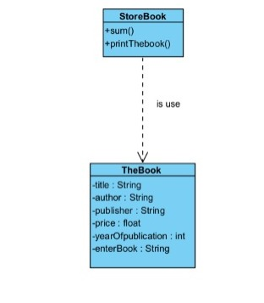

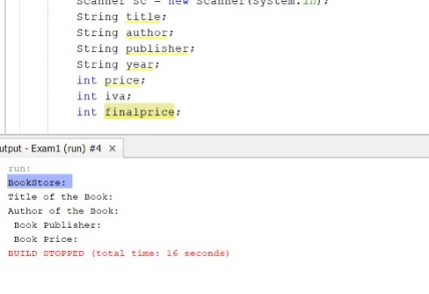

1) running program 6/10 pts.

2) Printing books on screen 5/10 pts.

3) Total amount of money for the books 0/10 pts.

4) Code Quality 7/10 pts.

5) UML Class Diagram 10/10 pts

Total: 28/50

19 GOMEZ DIAZ MELISSA MALAYCA  
diagrama   
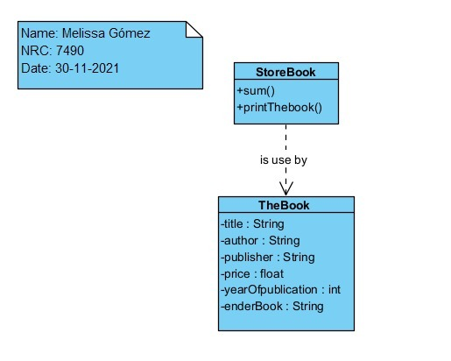  
1) running program 6/10 pts.

2) Printing books on screen 5/10 pts.

3) Total amount of money for the books 4/10 pts.

4) Code Quality 5/10 pts.

5) UML Class Diagram 10/10 pts  
  
Total point 30/50

Inpection :Angel Guaman

20 GUAMAN VEJARANO ANGEL DAVID

1) running program 10/10 pts.

2) Printing books on screen 5/10 pts.

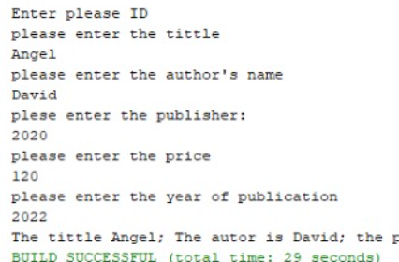

3) Total amount of money for the books 0/10 pts.

4) Code Quality 4/10 pts.

5) UML Class Diagram 7/10 pts

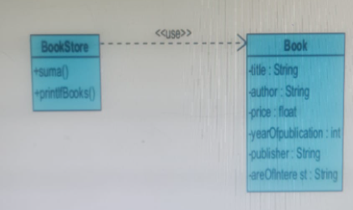

Total:26/50

inspector: Guitarra Jhon

21 GUITARRA SANCHEZ JHON ALEXANDER

Inspector: Jose Guzman

1) running program 0/10 pts.

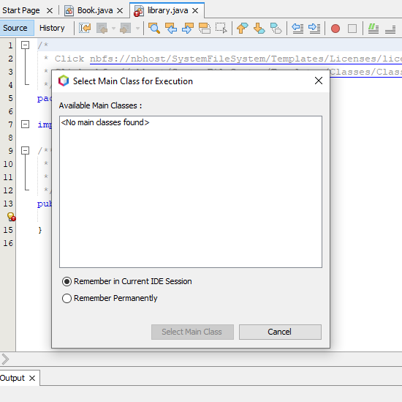

2) Printing books on screen 0/10 pts.

3) Total amount of money for the books 0/10 pts.

4) Code Quality 5/10 pts.

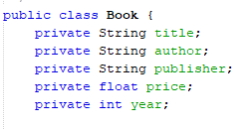

5) UML Class Diagram 10/10 pts

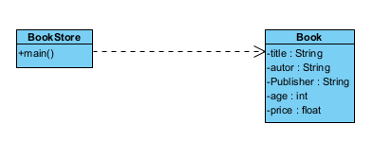

Total:15/50

22 GUZMAN LOPEZ JOSE DAVID

1) running program 10/10 pts.

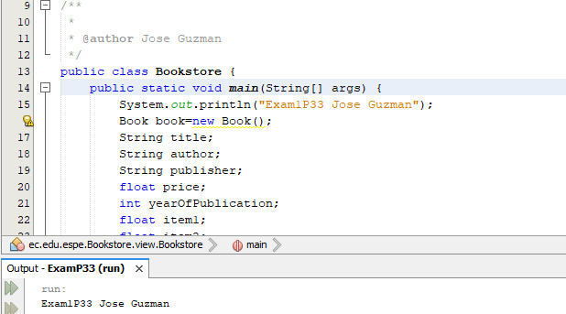

2) Printing books on screen 10/10 pts.

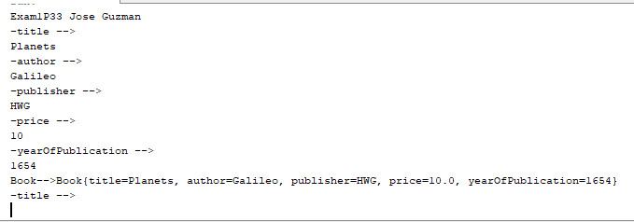

3) Total amount of money for the books 5/10 pts.

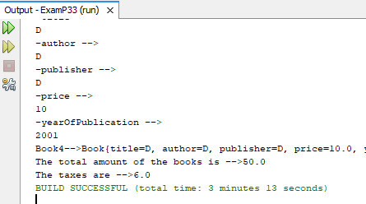

4) Code Quality 10/10 pts.

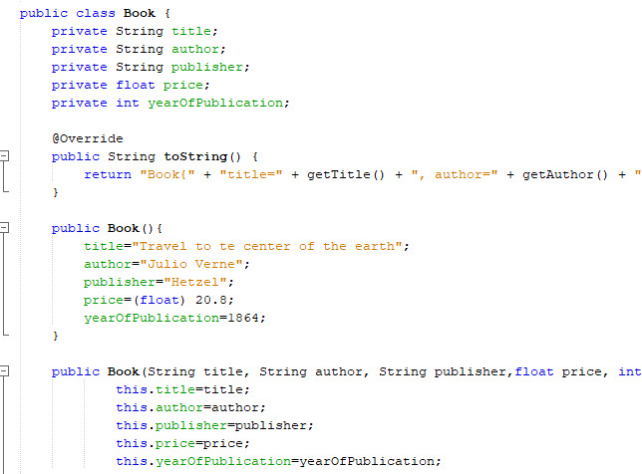

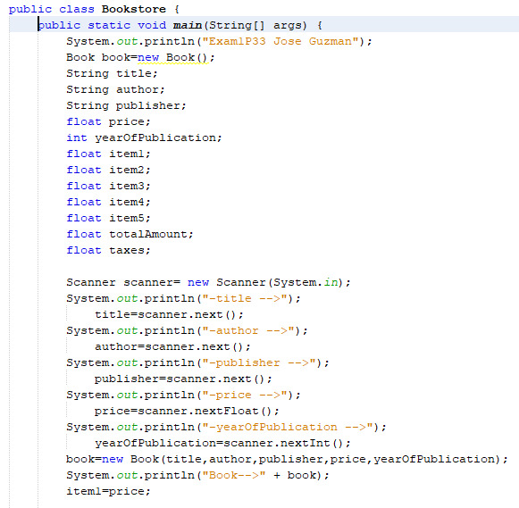

5) UML Class Diagram 5/10 pts

Total 40 /50

23 INSUASTI LOPEZ JONATHAN ESTEBA

Inspector Mateo Landazuri

1) running program 0/10 pts.

2) Printing books on screen 0/10 pts.

3) Total amount of money for the books 0/10 pts.

4) Code Quality 0/10 pts.

5) UML Class Diagram 5/10 pts

you have nothing code in the compressed drive folder

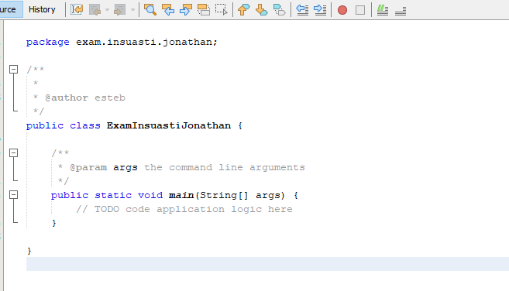

**24 LANDAZURI SEGOVIA MATEO ISRAEL**

**Inspector:Daniel Lincango**

1) running program 9/10 pts.

2) Printing books on screen 7/10 pts.

3) Total amount of money for the books 7/10 pts.

4) Code Quality 5/10 pts.

5) UML Class Diagram 4/10 pts

Total 32/50

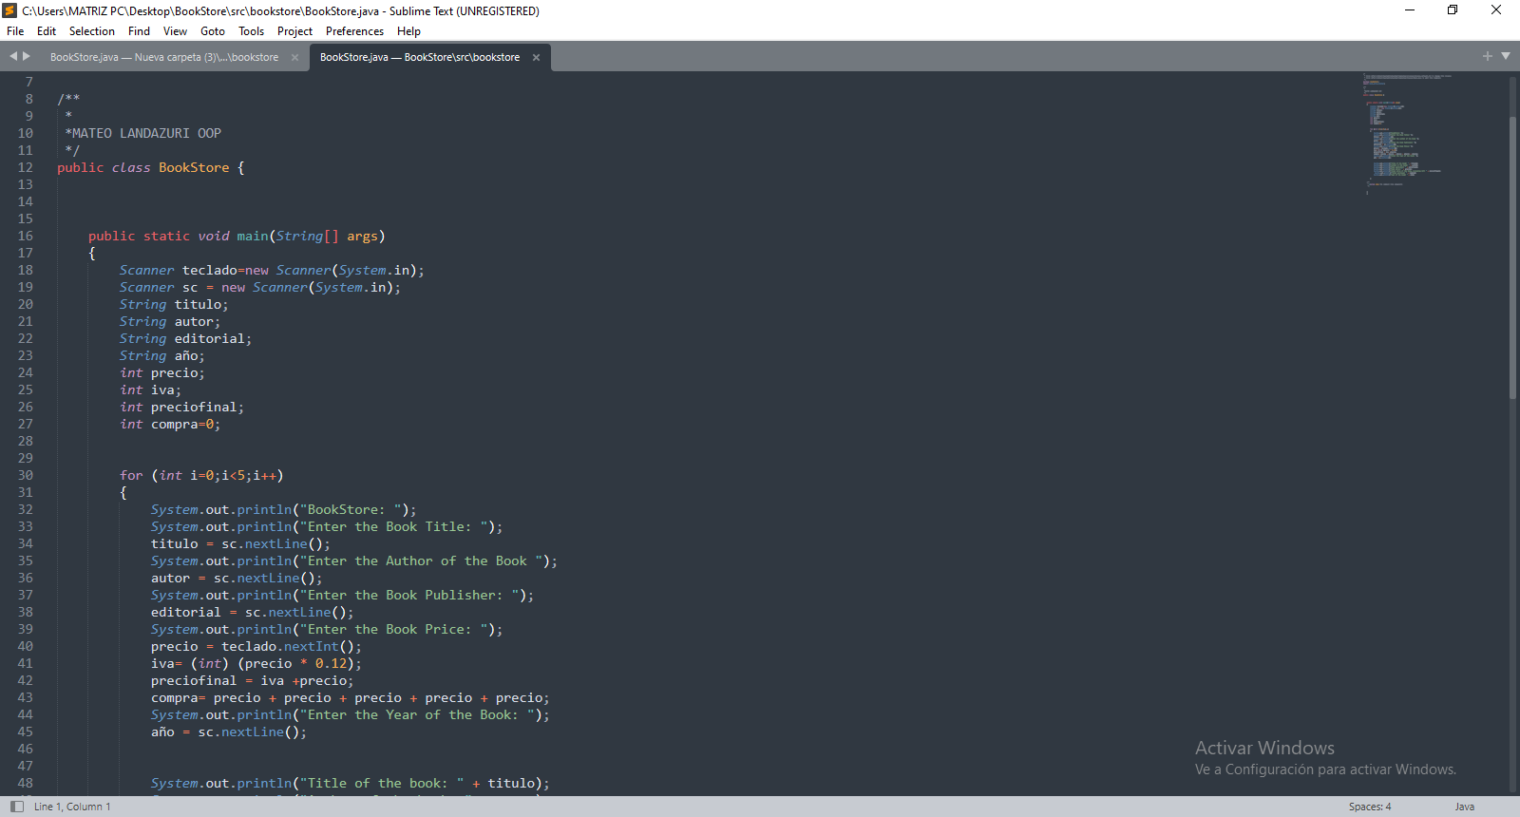

**25 LINCANGO CRIOLLO JOSE DANIEL**

Inspector:Maisincho Richar

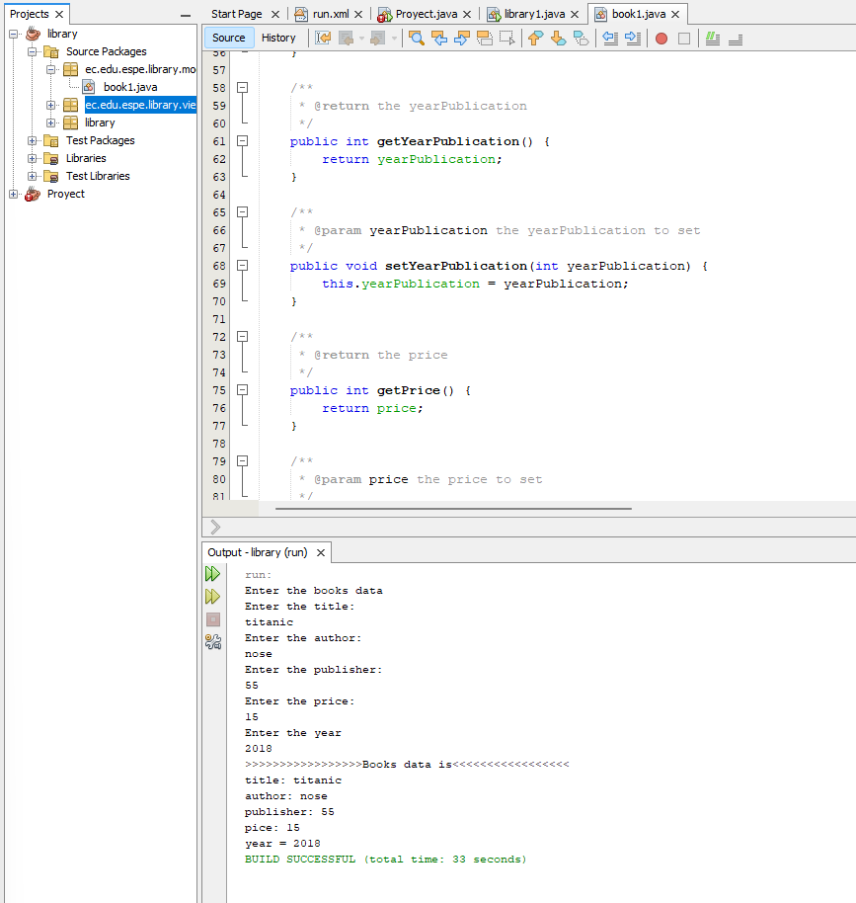

1) running program 10/10 pts.

2) Printing books on screen 10/10 pts.

3) Total amount of money for the books 7/10 pts.

4) Code Quality 8/10 pts.

5) UML Class Diagram 0/10 pts

Total 35/50

26 MAISINCHO PAUCAR RICHAR ALEXANDER

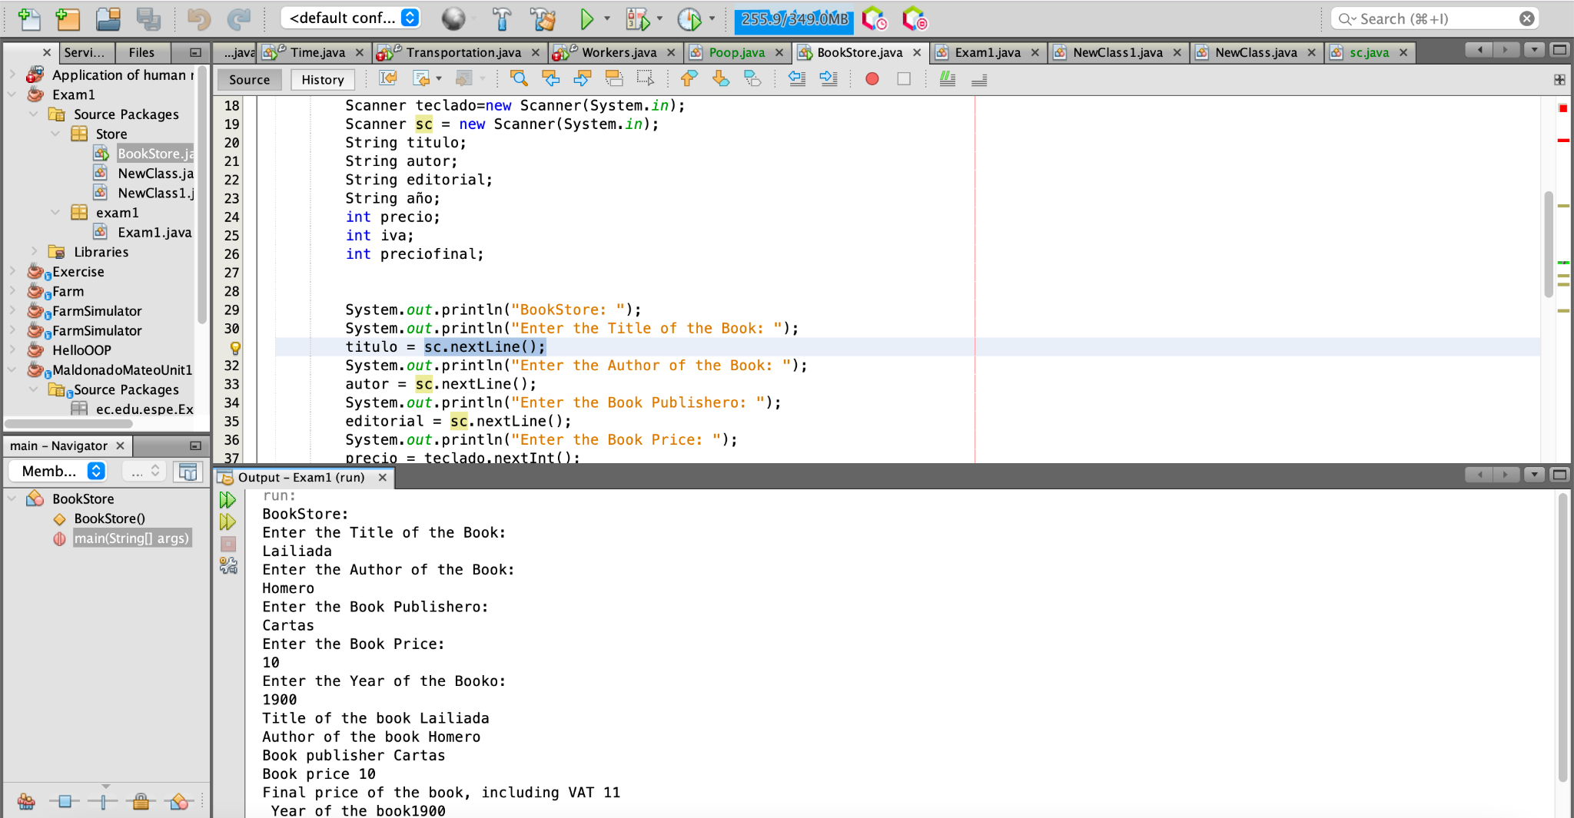

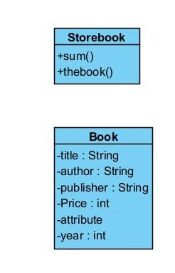

1) running program 10/10 pts.

2) Printing books on screen 6/10 pts.

3) Total amount of money for the books 6/10 pts.

4) Code Quality 7/10 pts.

5) UML Class Diagram 6/10 pts

Total 35/50

**27 MALDONADO BASTIDAS MATEO STEFANO**

Inspector: Leonel Mantuano

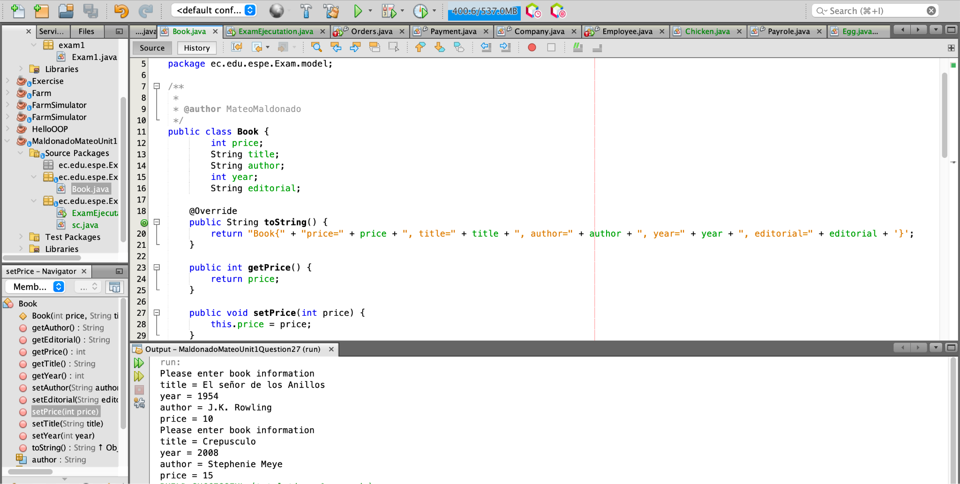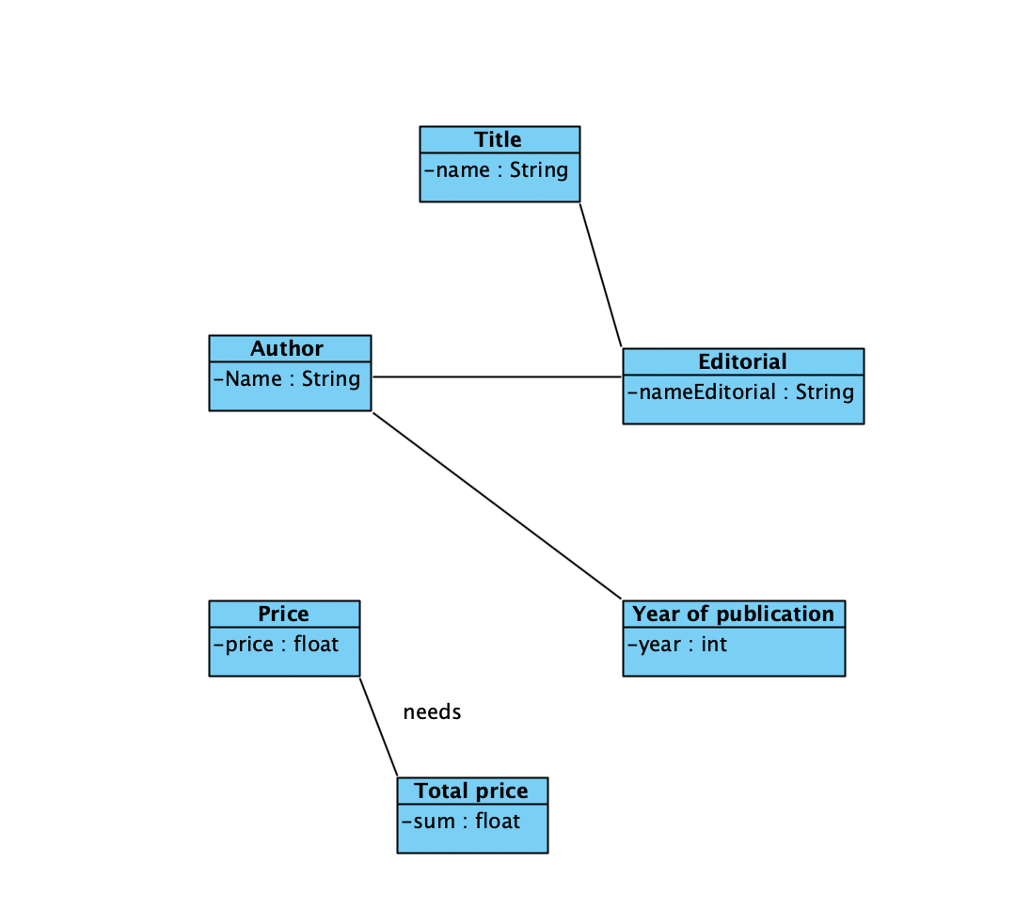

1) running program 10/10 pts.

2) Printing books on screen 6/10 pts.

3) Total amount of money for the books 5/10 pts.

4) Code Quality 6/10 pts.

5) UML Class Diagram 3/10 pts

Total 30/50

28 MANTUANO FERNANDEZ LEONEL FERNANDO

**Inspector:** Anthony Morales

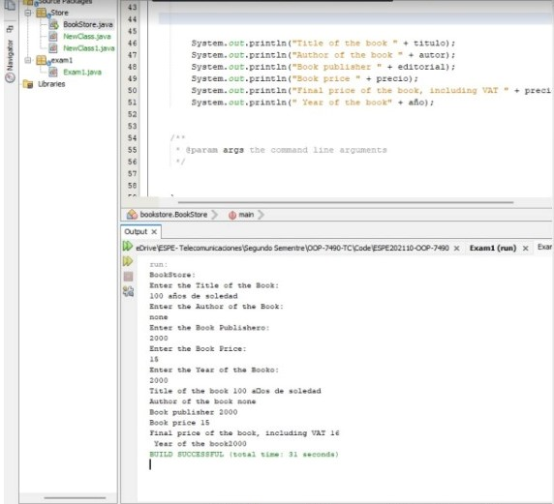

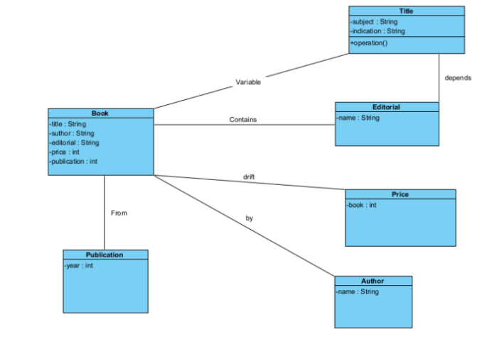

1) running program 9/10 pts.

2) Printing books on screen 6/10 pts.

3) Total amount of money for the books 7/10 pts.

4) Code Quality 7,5/10 pts.

5) UML Class Diagram 3/10 pts

Total: 32,5/50

29 MORALES CAICEDO ANTHONY JAVIER

Inspector: Sebastian Palacios

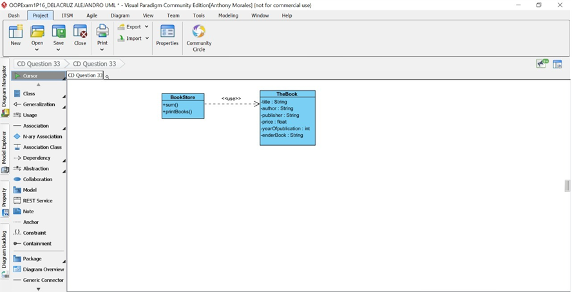

1) running program 2/10 pts.

2) Printing books on screen 0/10 pts.

3) Total amount of money for the books 0/10 pts.

4) Code Quality 6/10 pts.

5) UML Class Diagram 10/10 pts

Total : 18/50

30 PALACIOS CANDO DIEGO SEBASTIAN

Inspector: Javier Paucar

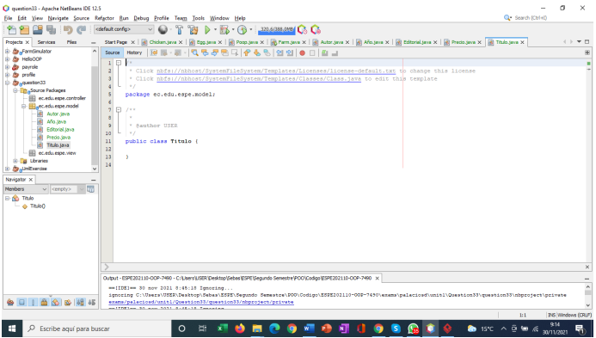

1) running program 5/10 pts.

2) Printing books on screen 2/10 pts.

3) Total amount of money for the books 0/10 pts.

4) Code Quality 10/10 pts.

5) UML Class Diagram 2/10 pts

Total : 19/50

31 PAUCAR LEMA ALEX JAVIER

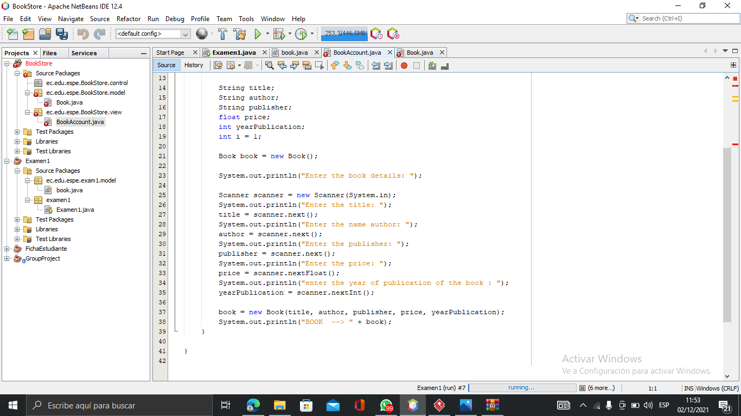

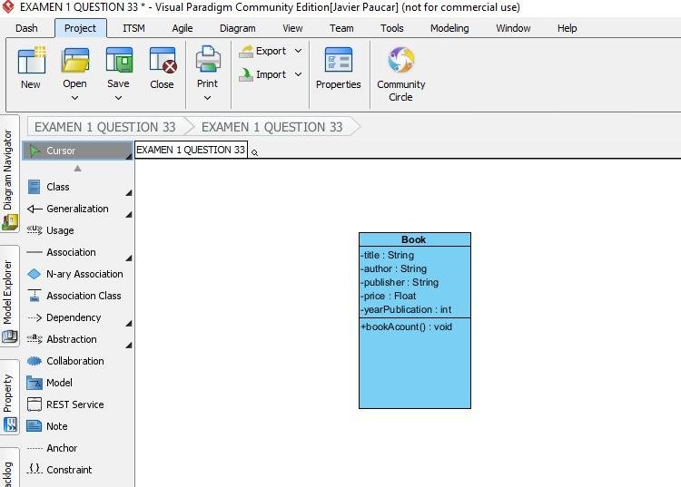

1) running program 6/10 pts.

2) Printing books on screen 10/10 pts.

3) Total amount of money for the books 0/10 pts.

4) Code Quality 9/10 pts.

5) UML Class Diagram 8/10 pts

total: 33/50

32 QUINGA GUAYASAMIN LEANDRO ALEXANDER

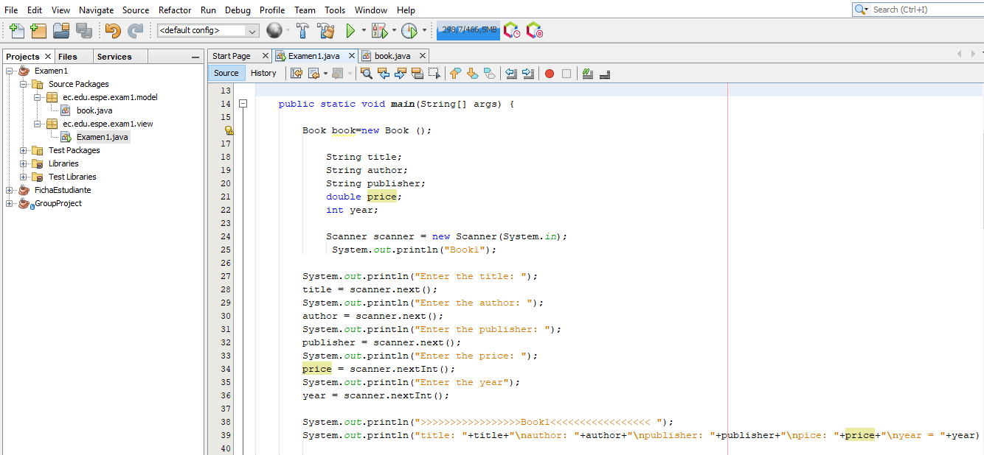

1) running program 10/10 pts.

2) Printing books on screen 8/10 pts.

3) Total amount of money for the books 0/10 pts.

4) Code Quality 7/10 pts.

5) UML Class Diagram 8/10 pts

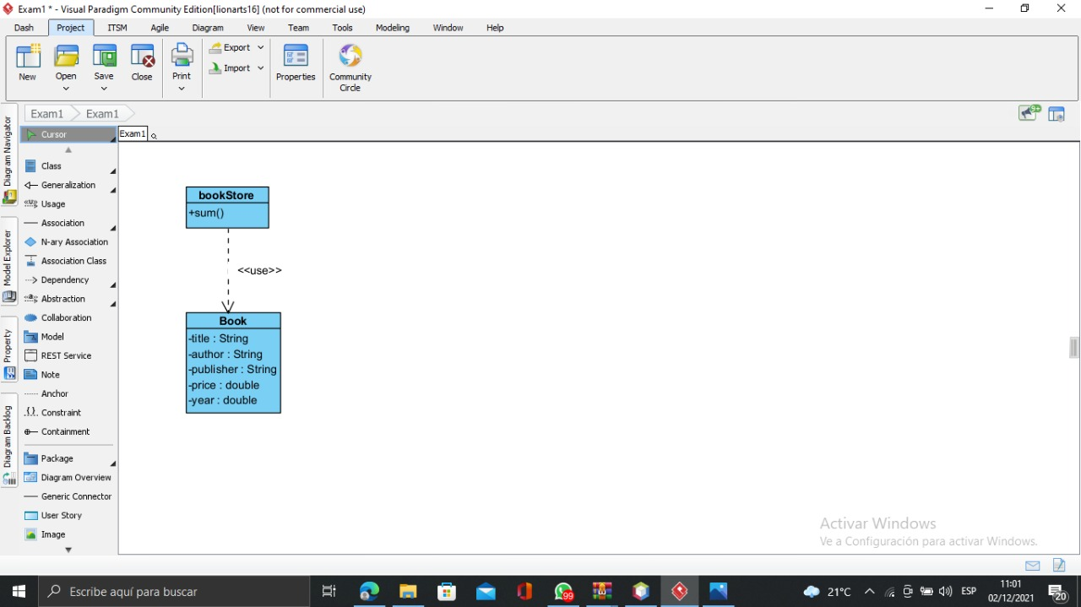

Total 33/50

33 RUANO PONCE ALEXANDER JAVIER

Inspector:Paul Saltos

1) running program 5/10 pts.

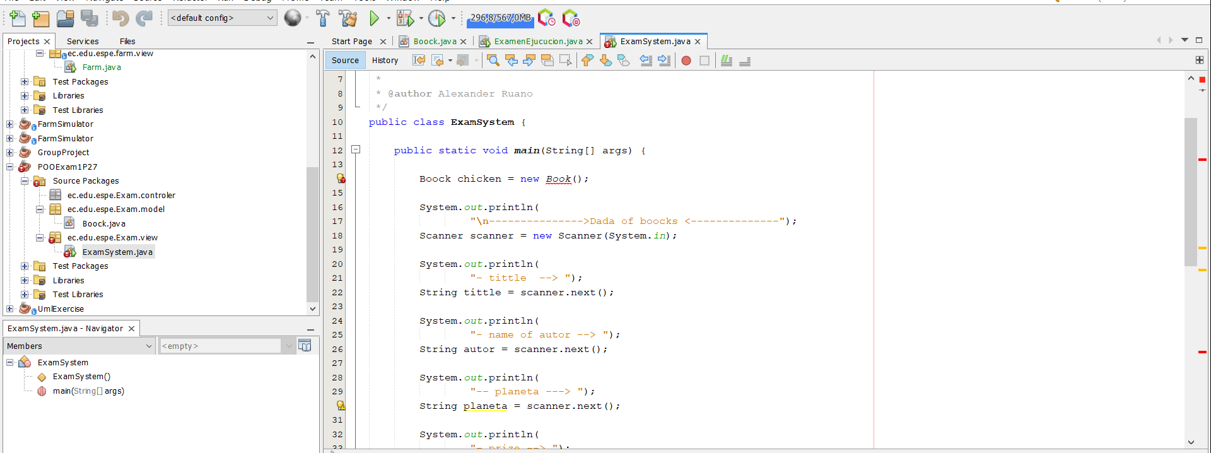

2) Printing books on screen 5/10 pts.

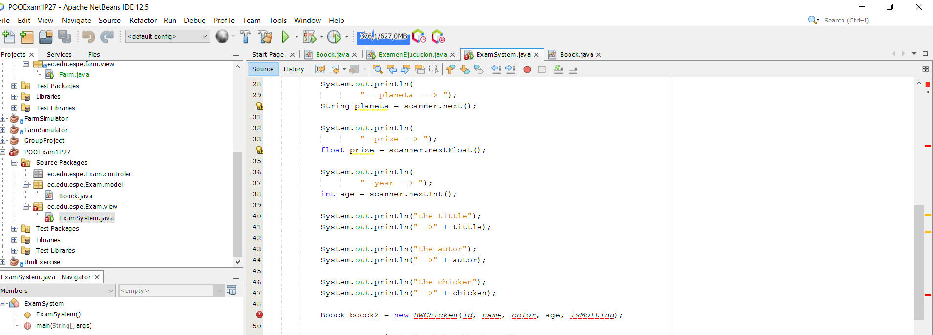

3) Total amount of money for the books 0/10 pts.

4) Code Quality 10/10 pts.

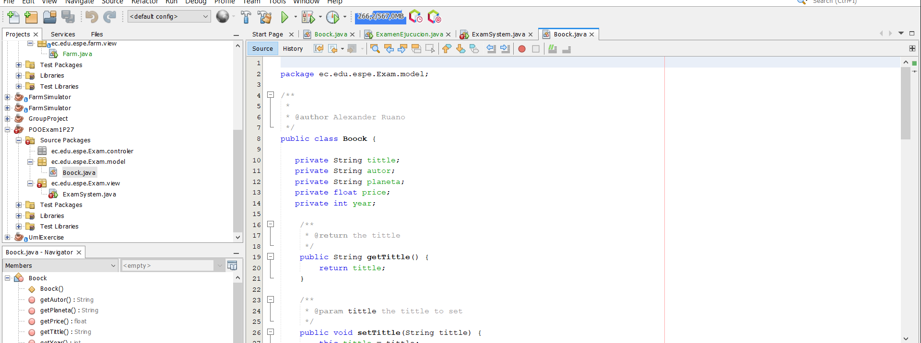

5) UML Class Diagram 10/10 pts

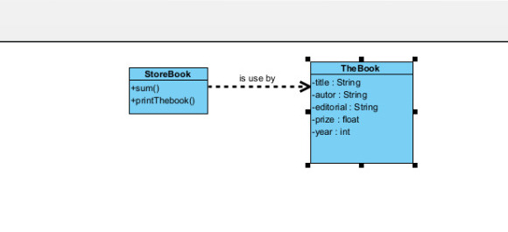

Total:36/50

34 SALTOS TACO PAUL ALEXANDER

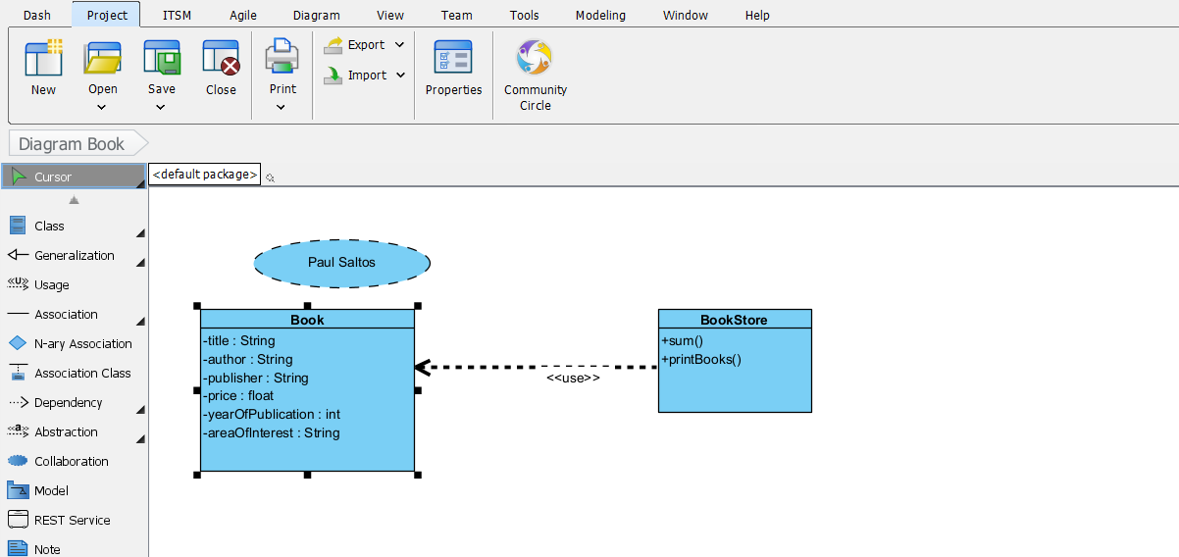

1) running program 0/10 pts.

2) Printing books on screen /10 pts.

3) Total amount of money for the books /10 pts.

4) Code Quality /10 pts.

5) UML Class Diagram 10/10 pts

Total

35 SANCHEZ MISHQUERO JOSE FRANCISCO

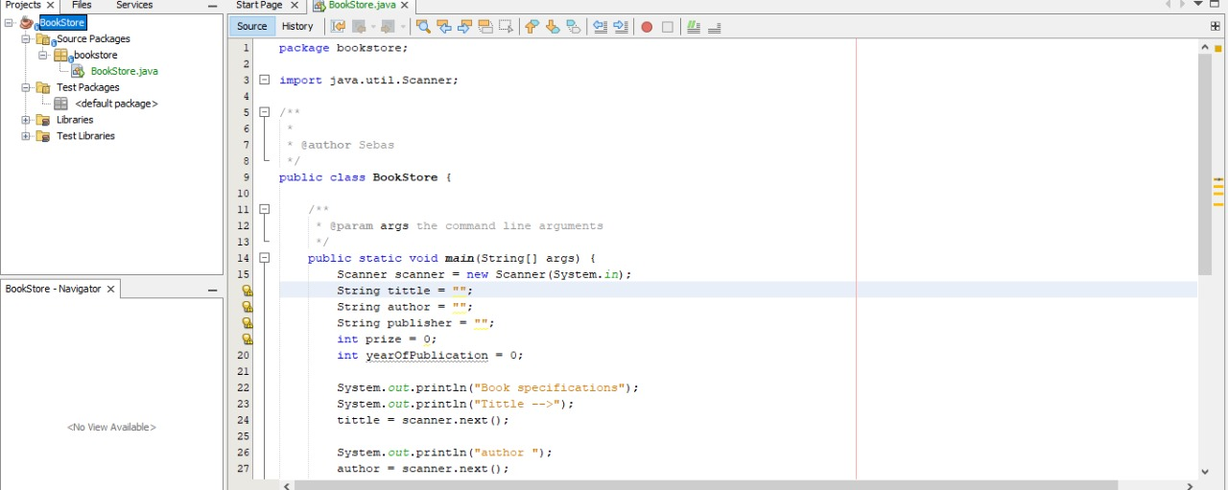

1) running program 0/10 pts.

2) Printing books on screen 0/10 pts.

3) Total amount of money for the books 8/10 pts.

4) Code Quality 10/10 pts.

5) UML Class Diagram 10/10 pts

total:28/50

36 SHUGULI REINOSO ALAN JESITH

Inspector Simbaña Gustavo

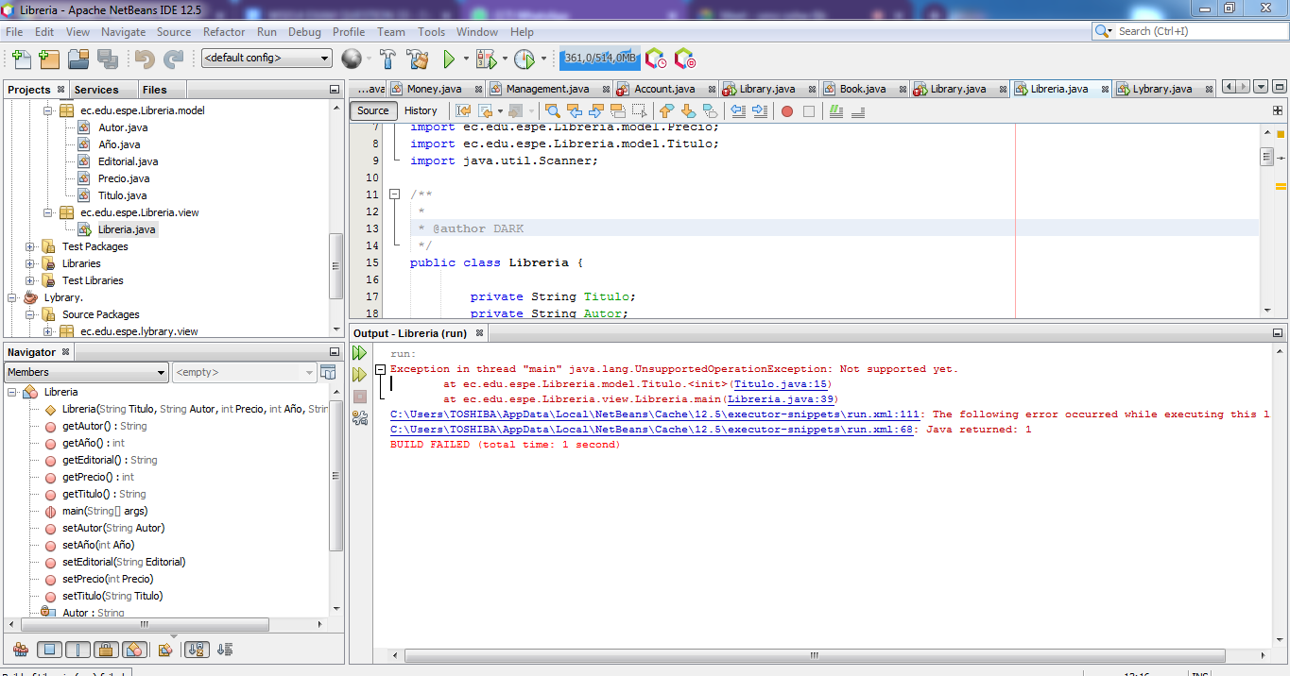

1) running program 0 /10 pts.

2) Printing books on screen 0/10 pts.

3) Total amount of money for the books /10 pts.

4) Code Quality 10/10 pts.

5) UML Class Diagram 0/10 pts

Total : 10 /50

37 SIMBAÑA SIMBAÑA JONATHAN GUSTAVO

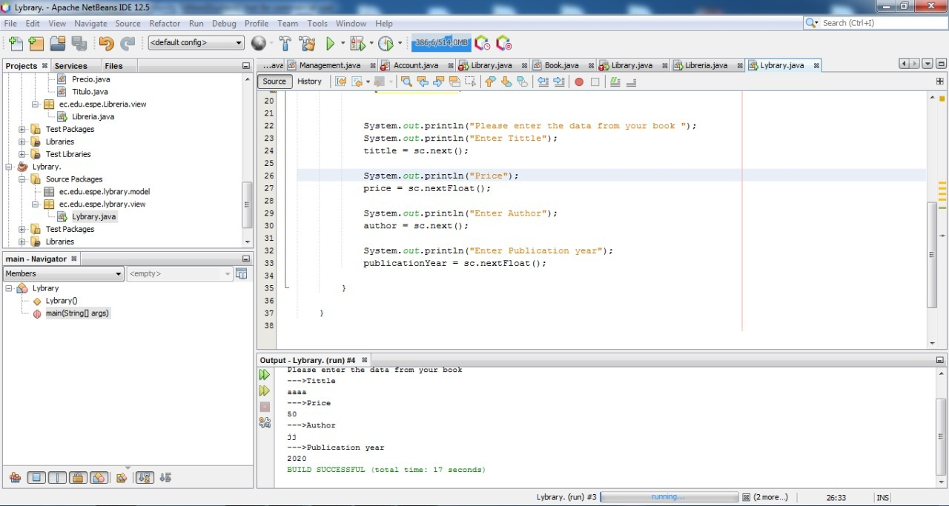

Inspector: Andrea Tapia

1) running program 10 /10 pts.

2) Printing books on screen 5/10 pts.

3) Total amount of money for the books 0/10 pts.

4) Code Quality 7/10 pts.

5) UML Class Diagram 0/10 pts

total 22

38 TAPIA ALBAN ANDREA JULIANNA

Inspector Sebastián tayo

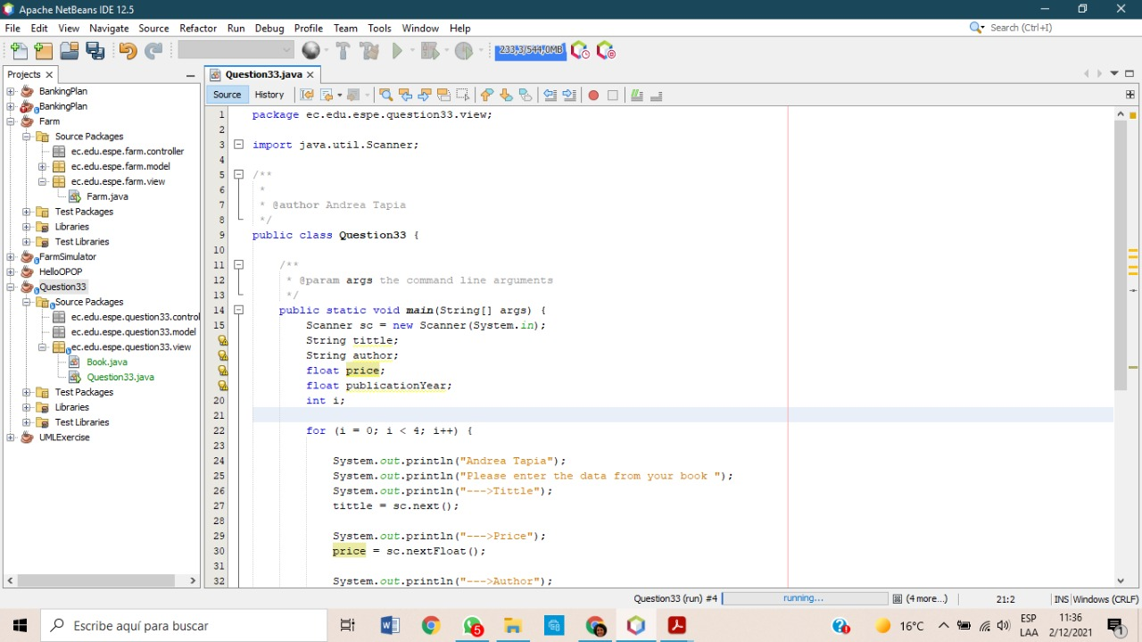

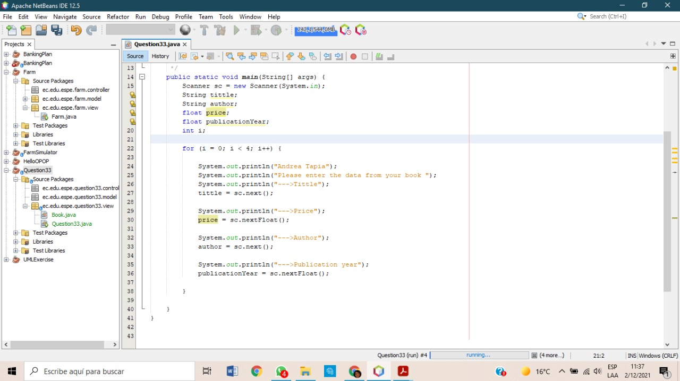

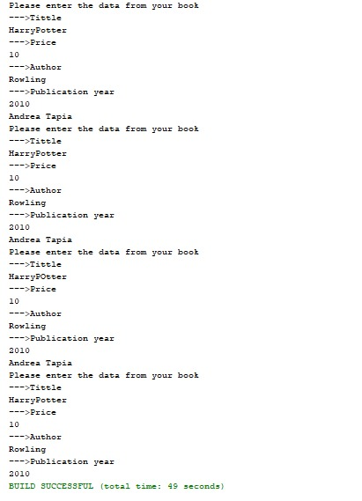

1) running program 10/10 pts.

2) Printing books on screen 10/10 pts.

3) Total amount of money for the books 0/10 pts.

4) Code Quality 7/10 pts.

5) UML Class Diagram 0/10 pts

total: 27/50pts.

39 TAYO RUIZ SEBASTIAN ALEJANDRO

Inspector: Camila Teca



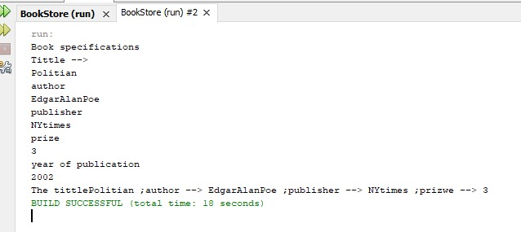

1) running program 10/10 pts.

2) Printing books on screen 2/10 pts.

3) Total amount of money for the books 0/10 pts.

4) Code Quality 3/10 pts.

5) UML Class Diagram 0/10 pts

Total : 15/50 pts

40 TECA TELLO CAMILA MILENA

Inspector: Melanie Terán

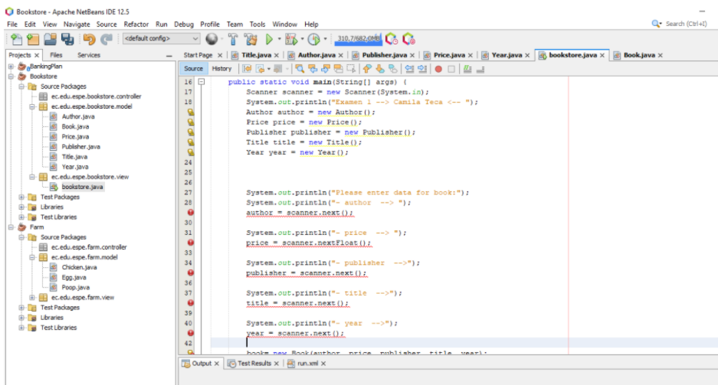

1) running program 0/10 pts.

2) Printing books on screen 0/10 pts.

3) Total amount of money for the books 0/10 pts.

4) Code Quality 9.5/10 pts.

5) UML Class Diagram 0/10 pts

41 TERAN FLORES MELANIE ELIZABETH

1) running program 10/10 pts.

2) Printing books on screen 10/10 pts.

3) Total amount of money for the books 0/10 pts.

4) Code Quality 10/10 pts.

5) UML Class Diagram 8/10 pts

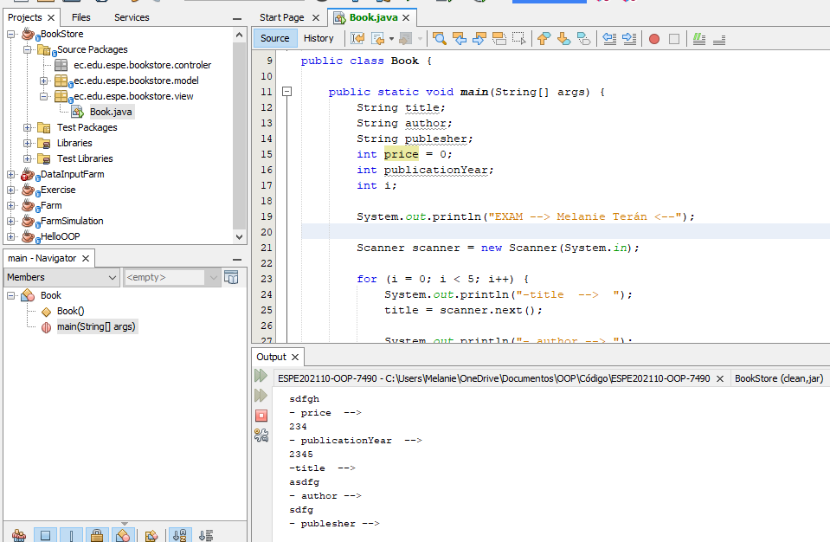

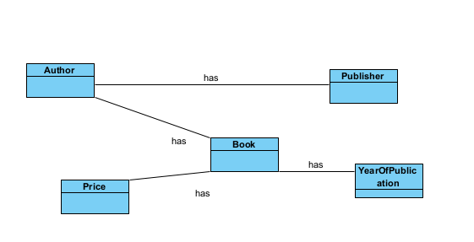

42 VILLEGAS ESTRELLA SALMA ABIGAIL

Inspector: Joel Zeas

1) running program 10/10 pts.

2) Printing books on screen 9/10 pts.

3) Total amount of money for the books 5/10 pts.

4) Code Quality 9/10 pts.

5) UML Class Diagram 0/10 pts

Total: 33

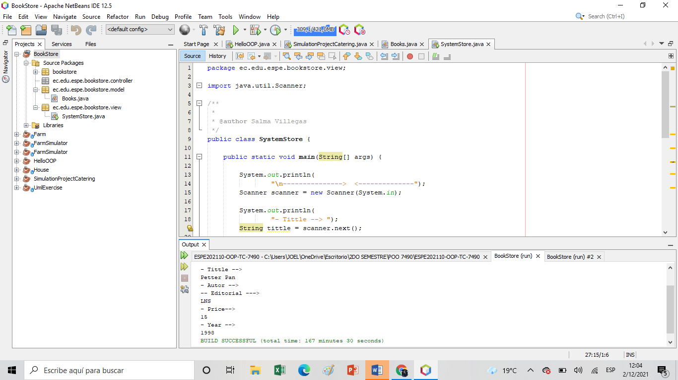

43 ZEAS CLAVIJO JOEL ALEXANDER

1) running program 8/10 pts.

2) Printing books on screen 7.5/10 pts.

3) Total amount of money for the books 5/10 pts.

4) Code Quality 7.5/10 pts.

5) UML Class Diagram 0 /10 pts

Total: 28 pts

